High Arsenic Concentration of Groundwater
in Mahananda Floodplain:
Distribution and Genesis Mechanism

M.S. Thesis
Roll : 1912560108
Session : 2022-2023
Department of Geology And Mining
University of Rajshahi

Supervisor
Md. Abdur Rahman
Professor
Department of Geology And Mining
University of Rajshahi

Abstract
Groundwater is the primary source of drinking and irrigation water in the Mahananda Floodplain of Bangladesh. However, elevated arsenic concentrations in groundwater have become a major environmental and public health concern in the region. This study aimed to investigate the spatial distribution of arsenic contamination, identify its genesis mechanism, determine possible contamination sources using statistical modeling, and assess the associated human health risks.
A total of 21 groundwater samples were collected from tube wells distributed throughout the study area. Physicochemical parameters, major ions, and trace elements, including arsenic (As), iron (Fe), and manganese (Mn), were analyzed using standard laboratory methods. Geographic Information System (GIS) techniques and Inverse Distance Weighting (IDW) interpolation were applied to map the spatial distribution of arsenic. Hydrogeochemical processes controlling arsenic mobilization were investigated through correlation analysis, Principal Component Analysis (PCA), Factor Analysis (FA), and Hierarchical Cluster Analysis (HCA).
The results revealed considerable spatial variability in arsenic concentrations, with several locations exceeding both the World Health Organization (WHO) guideline value of 10 µg/L and the Bangladesh drinking water standard of 50 µg/L. Spatial mapping identified contamination hotspots mainly in the central and southeastern parts of the floodplain. Strong positive associations between arsenic, iron, manganese, and bicarbonate, along with low dissolved oxygen conditions, indicated that reductive dissolution of iron oxyhydroxides is the dominant mechanism responsible for arsenic release into groundwater. Multivariate statistical analyses further confirmed that arsenic contamination is predominantly controlled by natural geogenic processes rather than direct anthropogenic sources.
Human health risk assessment indicated significant non-carcinogenic and carcinogenic risks associated with groundwater consumption. Most samples showed Hazard Index (HI) values exceeding the safe limit of 1, while all calculated cancer risk values exceeded the acceptable range recommended by the United States Environmental Protection Agency (USEPA). Sample 13 exhibited the highest risk, followed by Samples 8 and 20. Monte Carlo simulation with 10,000 iterations confirmed the reliability of the risk assessment and demonstrated that both adult and child populations are exposed to elevated health risks, with children being more vulnerable than adults.
Overall, the study demonstrates that arsenic contamination in the Mahananda Floodplain is primarily controlled by natural hydrogeochemical processes and poses significant risks to public health. Continuous groundwater monitoring, identification of safe aquifers, implementation of arsenic removal technologies, and sustainable groundwater management strategies are recommended to reduce exposure and ensure safe drinking water for the local population.
Keywords: Arsenic, Groundwater, Mahananda Floodplain, Spatial Distribution, Genesis Mechanism, PCA, Factor Analysis, Health Risk Assessment, Monte Carlo Simulation, GIS.

CHAPTER ONE
INTRODUCTION
1.1 Overview
Groundwater is an important natural asset that is essential to the Earth's hydrological processes and has long been a primary supply of drinking and irrigation water around the world (The World's Water 2008). Nonetheless, many countries are currently dealing with water scarcity and degradation of water quality as a result of increased levels of contaminants such as arsenic, iron, fluoride, salinity,& nitrate.
Arsenic pollution of sedimentary aquifers poses a significant concern to global health. Groundwater in Bangladesh, India, Nepal, Thailand, China, Taiwan, Vietnam, Chile, Hungary, and some parts of the United States has been found to contain high levels of naturally occurring arsenic (Smedley and Kinniburgh, 2002; Garcia-Sanchez and Alvarez-Ayuso, 2003). Notably, widespread groundwater contamination by arsenic in several regions of Bangladesh and West Bengal, India, is one of the world's most significant environmental disasters (Mukherjee and Bhatta-charya, 2001; Ahmed et al., 2004). There are serious health concerns associated with tens of millions of Bangladeshis and Bengalis drinking groundwater tainted with arsenic (BGS and DPHE, 2001). Arsenic is an abundant trace element in weathered soils and rocks. Arsenic could be derived via the oxidation of metal sulphides or the Himalayan orogenic belt's rock weathering in regions such as Chapai-Nawabganj, Northwestern Bangladesh (Nickson, 2000). Metal sulphides are assumed to be the primary source of arsenic, yet there is minimal evidence of a link between dissolved sulphate and arsenic in groundwater in Bangladesh (e.g., Nickson et al., 2000; Zheng et al., 2004).
Surface water transports released arsenic in aerobic circumstances, forming significant bonds with stream sediments and iron oxides (e.g., Nickson et al., 2000; McArthur et al., 2001; Ravenscroft, 2001). These sorbed sediments, which include biological elements, are then deposited in alluvial settings.
Through processes like the reductive reduction of iron and manganese oxides by iron (III)-reducing bacteria in conditions of moderate reduction, alluvial sediments go through a complicated process of mobilising arsenic (e.g., Saunders et al., 2005; Polizzotto et al., 2008). Moreover, arsenic may be mobilised by ionic competition with other ions such silicate, carbonate, and nitrate for sorption sites on oxides (Lee et al., 2005). Therefore, the fate and mobility of arsenic are determined by biogeochemical changes and desorption mechanisms in sediments (Peltier et al., 2003).

A major global concern is the predominance of saline groundwater, especially in areas with scarce water supplies (Lapworth et al., 2017; Vengosh and Rosenthal, 1994; Wang and Jiao, 2012). The problem of "salinity" is only superficial, though, because higher salinity levels are frequently associated with higher concentrations of different inorganic contaminants, including arsenic (Rango et al., 2013; Scanlon et al., 2009), boron (Deng et al., 2009; Smedley et al., 2005), fluoride (Jacks et al., 2005; Li et al., 2019), selenium (Naftz et al., 2008; Santucci et al., 2016), and sulfate (Avrahamov et al., 2014; Guo and Wang, 2005), selenium (Avrahamov et al., 2014), and boron (Deng et al., 2009; Smedley et al., 2005). The high salinity level significantly reduces groundwater's usefulness for industrial, agricultural, and residential uses. Increased salinity levels can also have a negative impact on the flavor of drinking water and cause major health problems (such as kidney damage from consuming too much salt; González et al., 2015; Torres et al., 2017). Due to their ability to impede nitrogen uptake, limit development, and prevent plant reproduction, salts can have an adverse effect on crop, tree, and pasture productivity (Holland et al., 2015; Jesus et al., 2015). Salinity increases the likelihood of soil erosion since it is frequently associated with extended periods of precipitation and a lack of surface cover (Aleksandrova et al., 2014; Renaud et al., 2015).

1.2 Regarding Arsenic
Arsenic belongs to the VA group of the periodic table and is categorised as a metalloid. It is colourless, odourless, and tasteless, and it occurs naturally in both grey and yellow crystalline forms. With a sublimation point of 650°C, arsenic is also recognised to be an effective heat and electrical conductor (Dara, 1995). There are more types of arsenic known as allotropes in addition to the grey and yellow versions.

1.2.1 Chemistry
Arsenic is present in a wide variety of ecosystems, often at varying concentrations, including soils, rocks, water, air, flora, and animals. It typically forms bonds with elements like oxygen, sulphur, and chlorine. The largest concentrations of minerals are found in the arsenides of gold, silver, copper, iron, and lead. The main minerals that contain arsenic (FeAsS), realgar (As4S4), trisulfide of arsenic (As2S3), and orpiment are called arsenopyrites (Figure 1.2).

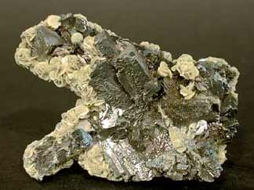


(I) (II)
Figure 1.1 (I) Arsenopyrite, (II) Arsenite (Rashid, M.R. and Mridha, M.A.K, 1998)

1.2.2 Minerals

The purest form of arsenic metal is rarely seen in nature. Most arsenic minerals are arsenopyrites, which are a combination of arsenic, iron, and sulphur. The arsenic sulphide minerals Realgar, Orpiment, and Enargite are less common. Elemental arsenic, arsenates, arsenites, arsenides, sulphides, and oxides are among the forms of arsenic found in nature. More than 200 different minerals and the byproducts of their alteration contain arsenic (WHO, 2001). The majority of these minerals are either ore minerals or their derivatives, despite their extreme rarity in the Earth's crust. The highest levels of arsenic are found near D-Block elements, according to DPHE/BGS/DFID (2001). (Transition metals) as well as Pb, Cd, Ag, Au, W, P, Sb, and Mo. Table 1.1 is a list of the most prevalent arsenic minerals.

Sedimentary Rocks and Arsenic: Concentrations of arsenic in sedimentary Typically, rocks contain 5–10 mg/kg; sand and sandstone have on average, around 1 mg/kg, whereas argillaceous sediments have higher levels, with an average of about 13 mg/kg (Webstar, 1999; Ure and Berrow, 1982). Concentrations of arsenic in bituminous deposits, coal, and black shale are frequently extremely high. The amounts of arsenic in carbonate rocks include typically low (around 3 mg/kg), but they can be noticeably higher in some ironstone and iron-rich rocks (WHO, 2001). Arsenic values in sediment samples from the Ganges and Meghna rivers are approximately 2 mg/kg and 3.5 mg/kg, respectively (Datta and Subramanian, 1998). Global averages for soil arsenic concentrations have been found to range between 7.2 mg/kg and 11.3 mg/kg, with normal amounts between 5 and 10 mg/kg (Boyel and Jonassaon, 1973; Shacklette et al., 1974; Ure and Berrow, 1982). Paddy fields in the research area have arsenic values ranging from 16.55 to 40.2 mg/kg, whereas vegetable fields have concentrations between 4.54 and 10.31 mg/kg.

Table 1.1 Major kinds of naturally occurring minerals containing arsenic.
Minerals | Composition | Occurrence
Native Arsenic | As | Hydrothermal Veins
Niccolite | Nias | Norites and vein deposits
Realgar | AsS | Hot spring deposits as well as vein deposits, which are frequently connected to orpiment, clays, and limestone
Orpiment | AS2S3 | Hot springs, volcanic sublimation product, and hydrothermal veins
Cobaltite | CoAsS | deposits at high temperatures and metamorphic rocks
arsenopyrite | FeAsS | The most prevalent As mineral veins that are mostly mineral
Tennantite | (Cu, Fe)12As4S13 | Hydrothermal veins
Enargite | Cu3AsS4 | Hydrothermal veins
Arsenolite | As2O3 | Arsenopyrite, native arsenic, and other minerals oxidize to create secondary minerals.
Claudetite | As2O3 | Arsenopyrite, a secondary mineral, is created when realgar oxidizes.
Scorodite | FeAO4.2H2O | supplementary mineral
Annabergite | (Ni, Co)3 (AsO4)2.8H2O | supplementary mineral
Hoernesite | Mg3(AsO4)2.8 H2O | Secondary mineral, smelter wastes
Haematolite | (Mn,Mg)4Al(AsO4)(OH)8
Conichalcite | CaCu(AsO4)(OH) | Secondary mineral
Pharmacosiderite | Fe3(AsO4)2(OH)3.5H2O) | Arsenopyrite and other As minerals' oxidation result

Arsenic in Metamorphic Rocks: Igneous and sedimentary rocks combine to form metamorphic rocks. Because of this, the levels of arsenic in metamorphic rocks also match those in their precursors. Most of them contain m mg/kg or less. Certain pelitic rocks, such slate and phyllites, typically have the highest concentrations, with an average of 18 mg/kg.

Unconsolidated sediments and soils: Arsenic concentrations in unconsolidated sediments are comparable to those in rocks; muds and clays, in particular, have higher arsenic concentrations than carbonates and sandstones (WHO, 2001). Depending on the mineralogy and texture, values typically range from 3 to 10 mg kg. According to Datta and Subramanian (1997), the average arsenic concentration in the Ganges River sediments was 2.0 mgkg (range 1.4-5.9 mgkg), but the average arsenic concentration in the Meghna River sediments was 3.5 mgkg (range 13.5.6 mgkg). Relative arsenic enrichment has been observed in reducing sediments in both near-shore continental shelf deposits (Peterson and Carpenter, 1986; Legeleux et al., 1994). In continental shelf sediments, concentration increases with depth (up to 30 cm) due to the formation of more reducing circumstances (Legeleux et al., 1994). Concentrations of arsenic in soil that have been established are typically in the range of 5–10 mg/kg. Boyel and Jonassaon (1973) reported that the average global soil had 7.2 mg/kg of arsenic, whereas Shacklet al. (1974) reported that of 7.4 mg/kg on average. 11.3 mg/kg was the higher average value reported by Ure and Berrow (1982). Given that geology is the principal arsenic source found in soils, soil concentrations are somewhat influenced by the concentrations of the element in the current rock components. Local sources of additional inputs could include phosphate fertilizer, insecticides, and groundwater heavy in arsenic, as well as industrial sources like smelting and results from burning fossil fuels.

1.3 Arsenic Interaction in Sediments
Iron oxides—metal oxides, notably iron, aluminium, and manganese—are the minerals that blind arsenic in aquifers because of their abundance and strong binding affinity. Clays and carbonates also absorb arsenic because their edges resemble oxides. Edwards (1994) states that aluminium hydroxides are better at adsorbing As (V) below pH 7.5 (on a molar Fe-Al basis), but iron salts are better at adsorbing As (III) at higher pH values. Since (V) is thought to be strongly absorbed by calcium carbonate (CaCO3), similar to phosphate, this could reduce the amount of arsenic present in groundwater from limestone aquifers (WHO, 2001).

1.4 Groundwater Arsenic Sources in Bangladesh
Where arsenic originates and how it enters Bangladesh's groundwater is still up for debate. Nonetheless, it is now widely accepted that the elevated arsenic levels in Bangladesh's groundwater come from a naturally occurring geological source, possibly as a result of water extracted during the Quaternary from restricted and partially restricted alluvial or deltaic aquifers. Numerous chemical and biological processes, such as oxidation, reduction, adsorption, precipitation, methylation, and volatilisation, actively cycle this hazardous element in the groundwater table (Figure 1.3) (Islam, 2007). Because these processes affect the availability of arsenic, arsenic invertebrates control the amounts of arsenic that are effectively exposed to people rather than surpassing the overall amount of arsenic. The two primary mechanisms that account for the majority of arsenic contamination are reduction of oxy-hydroxide and oxidation of ferrous hydroxides or arsenic pyrites.
1.5 Arsenic's Toxic Effects on Human Health
Arsenic is a poison that is harmful to human health. Its toxicity is categorized into acute, sub-acute, and chronic levels based on the amount of arsenic ingested. It kills silently. This substance is four times more toxic than mercury, with a fatal dosage (LD) of 125 milligrams for humansThe last form of toxicity, arsenic poisoning, is brought on by drinking water that has been tainted in an imperceptible way. Depending on the amount of arsenic consumed, the person's nutritional state, and immune response, the illness can take 8 to 14 years to manifest. In addition to being dose dependent, arsenic toxicity also builds up inside the body and eventually comes out through the nails and hair inside the body and eventually comes out through the nails and hair. It also relies on how quickly the body absorbs and gets rid of arsenic chemicals. The body excretes most of the arsenic it consumes through the skin, hair, nails, urine, and breath. Excessive consumption of arsenic causes some of it to build up in tissues, which stops biological enzymes from functioning. The main ways that Arsenic exposure in humans occurs through skin contact, inhalation, and ingestion. Strong evidence suggests that drinking water contaminated with arsenic increases the risk of bladder, lung, kidney, liver, colon, and prostate cancers in addition to the long-term relationship between arsenic intake and skin cancer. According to Engel and Smith (1994), A variety of non-neoplastic illnesses, including diabetes mellitus, heart disease, cerebrovascular disease, lung disease, and problems with the arteries, arterioles, and capillaries, have also been connected to arsenic exposure. Individuals who suffer from chronic Hepatitis B, are undernourished, or lack sufficient protein in their diet may be particularly vulnerable to the harmful effects of arsenic. (WHO, 1999). Children and the elderly might also be particularly vulnerable demographics. Below is a list of the conditions and body parts that arsenicosis usually affects. Table 1.2. Arsenic poisoning symptoms include tingling in the hands and feet, partial paralysis, diarrhea, thickening and darkening of the skin, and blindness.
Table 1.2 Infections of Arsenic.
Organ System | Problems
Skin | Benign illness, squamous cell carcinoma, basal cell carcinoma, symmetric hyperkeratosis of the palms and soles, and melanosis or depigmentation.
Liver | Jaundice, cirrhosis, enlargement, and non-cirrhotic portal hypertension
Nervous System | Sensory neuropathy and auditory impairment
Cardiovascular System | Acrylagocyanosis and the Raynaud's Syndrome
Hemopoietic System | Megalobastosis
Respiratory System | Lung Cancer
Endocrine System | Gout and diabetes mellitus
1.7 Location and Extent
Chapai Nawabganj District is a district of Rajshahi Division. The Rajarampur, Jorgachi,Baragharia, Maharajpur, Ranihati, Durlovepur,Shivganj stadium ,and Baliadanga Unions are included in the research area, Chapai Nawabganj Sadar Upazila, encompassing the Municipality of Chapai Nawabganj. It is located in the north-western part of Bangladesh. Latitude: 24° 36' 0.00“ N Longitude: 88° 16' 0.12" E This study area is adjacent to the Bay of Bengal.
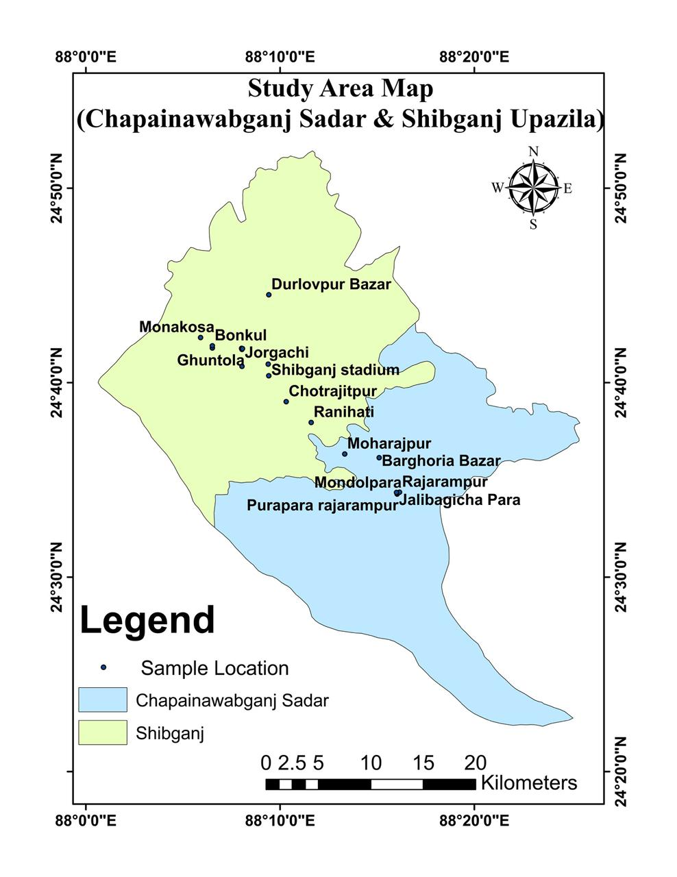
Figure 1.2 The study area's location is shown on figure.(Source ArcGIS)

1.8 Purpose and Scope
This research project was conducted after obtaining approval from the Academic Committee of the Department of Geology and Mining, prerequisites for the Master of Science degree at the University of Rajshahi (Thesis Group) in Geology and Mining. The study focused on assessing areas prone to arsenic contamination and Map the spatial distribution of arsenic-contaminated groundwater. It helps to test the hypothesis of the realease mechanism of Arsenic.
1.9 Statement of the Problem
A small number of individuals affected by arsenic contamination have been identified in the study area .The total number of affected people has not been precisely calculated, but there is concern that the number may increase in the near future. Chemical analysis of groundwater reveals that most hand tube-wells contain arsenic levels exceeding both the WHO and Bangladesh Drinking Water Standard (BDWS) limits for arsenic
1.10 Objectives of the Study
The northwest part of Bangladesh has shown water contamination from arsenic in numerous studies. In order to identify zones prone to both arsenic and other trace elements, the lithological characterization of the subsurface of the study region is the main focus of my research. There will also be a geochemical analysis done. In order to identify places that are vulnerable for arsenic, the goal of this research is to have a thorough understanding of the geological composition and qualities.

In light of this, the current study will be conducted to look into the following goals:
- Map the spatial distribution of arsenic-contaminated groundwater.
- To test the hypothesis of the realease mechanism of Arsenic.
- Source identification using Statistical Modeling (Factor analysis ,Clust analysis).
- Provide mitigation and management strategies.

1.11 Previous Investigation
Groundwater research have been carried out by several entities in order to address Bangladesh's arsenic problem. NRECA (1975) tested arsenic and other factors in about 570 tube wells across the country. In order to detect arsenic, Bangladesh University of Engineering and Technology (BUET) examined over 1200 samples taken from irrigation wells in Northern Bangladesh. According to reports, Dhaka Community Hospital (DCH) and the School of Environmental Sciences at Jadavpur University (SOES) surveyed arsenic levels in about 22,000 wells throughout Bangladesh in great detail. In October 1999, a national survey was undertaken by the Department of Public Health Engineering (DPHE) and the United Nations International Children's Emergency Fund (UNICEF), with 51,000 samples evaluated.
The Groundwater Studies for Arsenic Contamination in Bangladesh project, funded by the UK Department for International Development (DFID), brought together the British Geological Survey (BGS), the Department of Public Health Engineering (DPHE) Bangladesh, and Mott MacDonald Ltd. (MML) to conduct the most extensive nationwide survey. The Rapid Investigation Phase, or Phase 1, of this project began in January 1998 and was finished by December 1998. As a result, a six-volume report was issued at the beginning of 1999. Entitled 'Arsenic Contamination of Groundwater in Bangladesh,' The project's second phase was finished by the end of March 2000., having come after Phase I. Four volumes include the project's findings.On the other hand, research on the salinity issue in Bangladesh's northwest region is lacking. However, the salinity-affected lower Atrai floodplain aquifer in Naogaon, in the northwest of Bangladesh, was studied using a mix of geophysical and hydro-chemical approaches (Mazumder et al., 2014).
Research carried out by Woobaidullah et al. (1996a, 1996b, and 1998) examined the characteristics, distribution, and prevalence of salty water as well as its appropriate use for irrigation in Manda Upazila. The Bangladesh University Grants Commission provided funding for these studies (UGC). Groundwater chemical analysis and geoelectric resistivity surveys were part of the study project. Nevertheless, no thorough effort was undertaken to pinpoint the process or processes that gave rise to groundwater's salinity and suitability for irrigation and residential use.

CHAPTER TWO
GEOGRAPHY AND GEOLOGY

Chapainawabganj Sadar, located in the northwestern part of Bangladesh, lies within the Bengal Basin, which is part of the broader Indo-Gangetic Basin. This region is characterized by relatively stable tectonic settings with low seismic activity compared to the tectonically active regions of the world. The Bengal Basin, where Chapainawabganj is situated, is a large sedimentary basin formed by the deposition of sediments from the Himalayan mountains, the Ganges-Brahmaputra-Meghna river systems, and the uplift of the Indian Plate.
2.1 Geography
2.1.1 Physiography
The research region includes the Ganges Floodplain, a physiographic unit in Bangladesh (Fig 2.1). The main river that flows through the research region is the Mahananda River (Fig. 2.1). In the southwest portion of the research zone, the Ganges River (Fig.2.1) likewise runs geographically from west to southeast. Quaternary sediment deposition governed and impacted structural activity (Bakr, 1976 and Gupta, 1978).
The study area can be subdivided into three main physiographic divisions:
- Platform:The area around Chapainawabganj Sadar is part of a stable platform in Stable the Bengal Basin. The region does not lie near active plate boundaries but is within the interior of the Indian Plate.
- Bengal Foredeep: The region is part of the Bengal Foredeep, which is a major tectonic and sedimentary feature of the Bengal Basin. The foredeep is a result of subsidence caused by the down
- Subduction Influence: To the east of Bangladesh, there is tectonic activity related to the subduction of the Indian Plate beneath the Burma Plate along the Indo-Burman Range ward movement of the Indian Plate beneath the weight of sediments deposited by rivers.
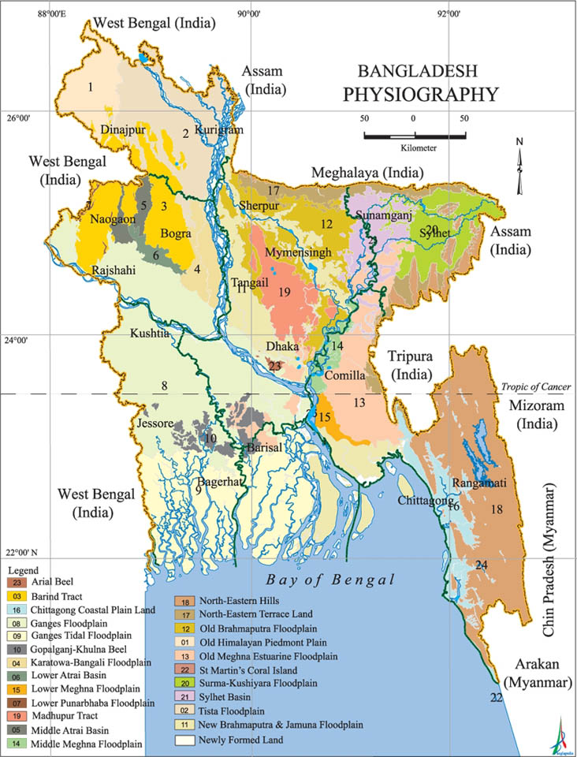Figure2.1:Physiographic Map of Bangladesh
2.1.2 Population
The 451.78 square kilometre Nawabganj Sadar Upazila is located between latitudes 24°25' and 24°43' north and longitudes 88°05' and 88°26' east. It is bordered to the north by Shibganj (Nawabganj) and Nachole Upazila, to the east by Tanore and Godagari Upazila, and to the west by West Bengal State, India.
There are 507483 Muslims, 20644 Hindus, 3 Buddhists, 1239 Christians, and 1223 other people among the 530592 total population, which consists of 254629 males and 275963 women. The Oraon, Santal, Mahali, Murari, and Pahan are among the indigenous groups that call this Upazila home. (Source: Bangladesh Bureau of Statistics, 2011 Population Census).

2.1.3Vegetation
The study area is well-vegetated and well-cultivated. Due to the rich soil of the floodplain and the tropical climate, most of the research area has an evergreen mantle. The research region has a well-developed vegetation that includes a variety of fruits, vegetables, trees, herbs, and other species.
A range of paddy crops, such as wheat, aman, aus, irri, and boro, are produced seasonally in the research area. Mango (Magnifera indica), jam (Syzgium jambolana), and jackfruit are among the most widely grown fruit-bearing plants. There are many types of wood available, such as Shishu, Koroi, Shimul, Babla (Acacia Arabica), and others.

2.1.4Climate
The research area's climate is typical of the subtropical monsoon climate of Asia. Its distinctive features include high temperatures, minimal precipitation, high humidity, and discernible seasonal variations. Three of the six seasons are particularly prominent.
The rainy season, which runs from June to September, accounts for about 80% of the total rainfall.
The season is hot and humid. It happens during the winter months of November through February. It's a very dry and cold season. In this case, March through April is considered the summer season. The wind becomes quite strong this time. There are intermittent thunderstorms and wind in this region, which is called Kalbaishaki. The greatest summertime temperature ever recorded was about 38.0ºC. The study area is associated with extremely hot summers and relatively low rainfall zone (Rashid,1997) (Figure 2.2).

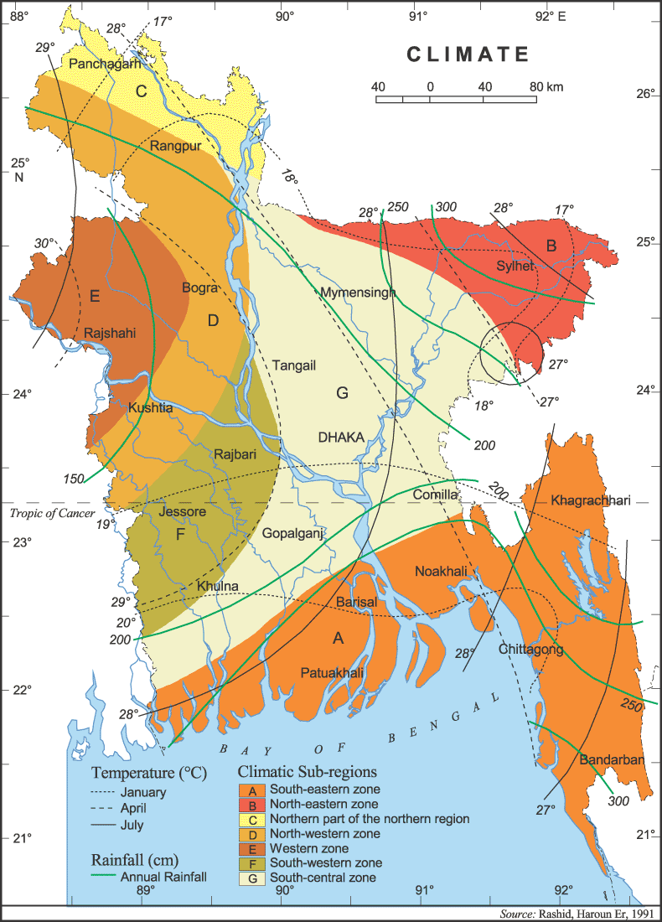
Figure 2.2 Climate map of Bangladesh (Rashid, Haroun Er, 1991)
2.1.4.1 The temperature

One of the most crucial and fundamental aspects of hydro-meteorology is the evaporation and precipitation of any area's temperature. According to an analysis of temperature data, the research area's monthly average maximum temperature ranges from 26.2 0C to 39.13 0C, while its average minimum temperature ranges from 14.53 0C to 28.91 0C (Table 2.1). The pre-monsoon season (usually March to June) has the highest temperatures, sometimes reaching 40 degrees Celsius, while the winter season (usually November to February) has the lowest temperatures, perhaps falling below 7 to 8 degrees Celsius.
Table 2.1 The research area's average monthly maximum and lowest temperatures in 2023. (Source. WeatherandClimate.com)
Month | Maximum (⁰C) | Minimum (⁰C)
January | 26.2 | 14.53
February | 30.42 | 17.63
March | 35.64 | 22.26
April | 39.13 | 26.77
May | 38.95 | 28.91
June | 37 | 29.05
July | 33.89 | 27.42
August | 33.72 | 27.14
September | 33.38 | 26.49
October | 32.1 | 23.92
November | 29.99 | 20.15
December | 26.92 | 16.57
Average | 33.12 | 23.4

Figure 2.3 Average monthly temperature data in the year of 2025 of the study

2.1.4.2Rainfall
Moderate rainfall with seasonal and regional variations is one of the research area's main characteristics. The average annual rainfall in the study area was roughly 1542.1 mm (Table 2.2). There is a lot of precipitation throughout the rainy season, which lasts from June to October. On rare occasions, cyclonic storms can also emerge and bring days or even weeks of heavy rain. About 80% of the total rainfall occurs during the monsoon and rainy season, with the remaining 20% occurring throughout the summer, pre-monsoon (March to May), and other seasons.
Table 2.2 Average monthly rainfall of the study area in the year of 2025. (Source. WeatherandClimate.com)
Month | Rainfall (mm)
January | 2.86
February | 9.55
March | 9.31
April | 65.19
May | 119.65
June | 169.33
July | 273.42
August | 204.21
September | 237.31
October | 68.8
November | 2.26
December | 1.86
Average | 96.98

Figure 2.3 Average monthly Rainfall data in the year of 2025 of the study

2.1.4.3Humidity
Humidity is one of the main factors influencing the evapotranspiration process. The study area's monthly average humidity in 2023 peaked in July (81.29%) and fell to its lowest point in April (35.68%) (Table 2.3). This implies that humidity is higher during the rainy season and lower throughout the winter.
Table 2.3 Average monthly humidity of the study area in the year of 2025 (weatherandclimate.com)
Month | Humidity (%)
January | 49.76
February | 41.68
March | 35.58
April | 45.74
May | 56.18
June | 67.82
July | 81.29
August | 81.56
September | 80.11
October | 72.98
November | 59.66
December | 52.25
Average | 60.38

Figure 2.5 Average monthly humidity of the study area in the year of 2025.

2.1.4.4SurfaceDrainage
Due to a variety of factors, including slopes, rock types, structural patterns, recent geological activity, and the geomorphic history of the area, the prevailing drainage pattern in the studied area has a sub-dendritic structure. The Padma, a major river in Bangladesh, borders the study area, while the Mahananda, the area's principal river, flows through it in the center. The Mahananda River and its tributaries, which flow from north to south, are the main sources of surface drainage in the surveyed area. The entire drainage system depends on the Mahananda River. The region also has a large number of ponds and Beels (wetlands), which are essential supplies of surface water for the locals' domestic usage, irrigation, and fishing. These bodies of water fluctuate, with many tiny ponds and Beels drying up in the summer and growing into enormous water sheets during the rainy season (Figure 2.6).
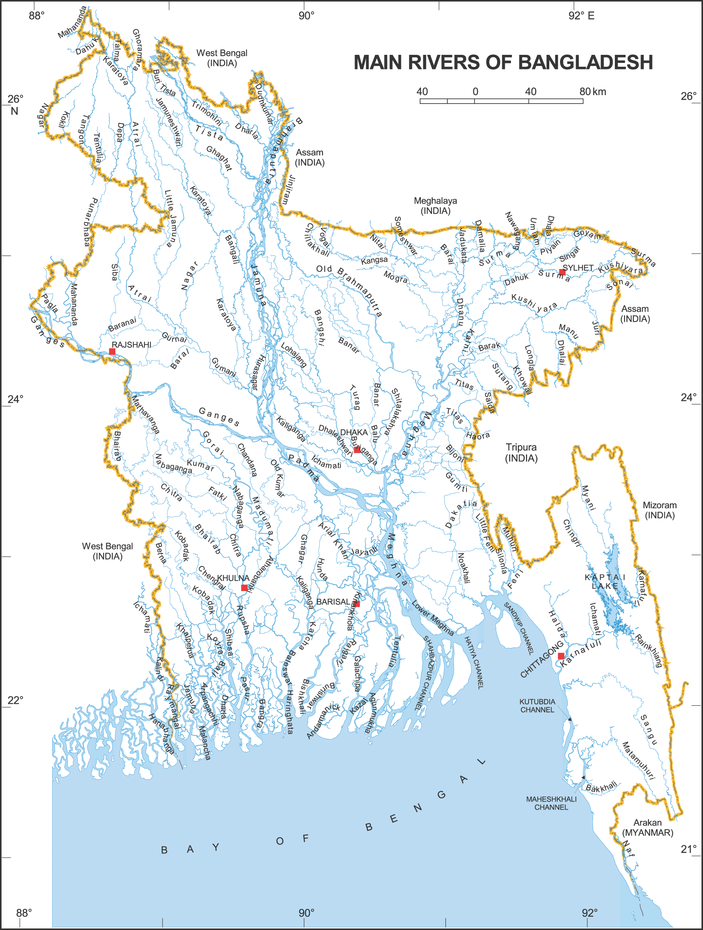
Figure 2.6 Map of the main river system of Bangladesh. (Source: Asiatic Society)

TheMahananda
The Mahananda, a major tributary of the Padma, mostly flows in the Chapai Nawabganj region (Fig. 2.6). The Mahaldiram in the Darjeeling district of India is where it all started. The river crosses the Indian border and enters the Chapai Nawabganj district around Bholahat, passing through Gomastapur and Chapai Nawabganj Sadar Upazila before meeting the Padma.
The systems of the Ganges and Padma rivers:
The Ganges River originates in the Himalayan Mountains near the Tibetan border and runs throughout India. The river first empties into the Chapai Nawabganj district near Shibganj, Bangladesh. To the west of Godagari town, a powerful river known as the Mahananda empties into the Ganges. The research region is bordered by the Padma River (Fig. 2.6).
2.2Geology
Understanding the geological context of any place, especially for hydrogeological reasons, requires an understanding of geology. Groundwater occurrence, flow, and storage are determined by the lithology, structure, thickness, and depth of various geologic formations as well as the predominant tectonic activity in that area (Todd, 1980).
Furthermore, an understanding of the terrain and its formation is necessary for catchment boundary definition, assessment of surface and groundwater resource management, and groundwater modelling for long-term production.
2.2.1Geological Setting by Region
The Bengal Basin, which comprises the majority of Bangladesh, was formed when the Indian plate separated from Gondwanaland during the Last Cretaceous and moved northward toward a collision with the Eurasian plate (Fig. 2.7).
Bangladesh is primarily composed of two tectonic units: the Stable Pre-Cambrian Platform in the northwest and the Geosyncline basin in the southeast. A tiny area known as the Hinge Zone, which tends northeast-southwest, separates the two groups mentioned above. These days, this hinge zone is referred to as a paleo-continental slope. The research area divides the tectonic subzones of the Rangpur Saddle and the Bogra Shelf.

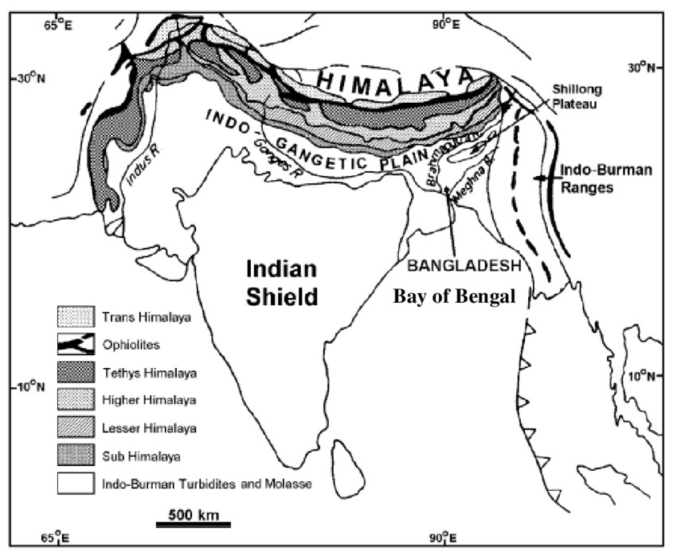

Figure 2.7 Tectonic map of Bangladesh and adjoining areas
The "Stable Pre-Cambrian Platform" is the name given to the stable shelf in the Bengal Basin that is situated to the northwest and west of the Hinge line, which connects Mymensingh and Calcutta.
The key zone of the basin's outward extension from the stable shelf is represented by this line, which is commonly known as the Kolkata-Mymensingh gravity line. The Dinajpur Slope, Rangpur Saddle, and Bogra Slope are the three primary zones that comprise the stable platform of the Bengal Basin within the Bangladesh part. This platform is an important geological structure in the area and is made up of continental crust covered in sediments from the Cretaceous to the present.

Sedimentary deposits from the Pre-Carboniferous period (between 360 million and 245 million years ago) with a significant coal content can be found in the isolated basins on the Stable Shelf. The sedimentary layer of the Bengal Basin's Stable Shelf varies in thickness from less than 200 meters to 8,000 meters. A large portion of the basin is covered by the Sylhet Limestone, which dates to the Eocene (between 58 million and 37 million years ago). In seismic reflections, this limestone layer acts as a crucial marker horizon that helps define the Stable Shelf's extend toward the basin.
The main mineral resources in Bangladesh's shelf and saddle regions are hard rocks, coal, and limestone. Additionally, the Sylhet limestone found on the stable shelf has the potential to serve as an oil and gas reservoir as well as a source rock.
The Indian Platform, Bengal Foredeep, Arakan Yoma Mega anticlinorium, and a tiny portion of Bangladesh's northwest in the Sub-Himalayan Foredeep are the country's main tectonic components, according to Bakhtine (1966) (Figure 2.8).
The Sub-Himalaya Foredeep separates the Indian Platform from the Himalayan Mega Anticlinorium, whereas the Young Arakan Yoma Mega Anticlinorium is separated from the Indian Platform by the Bengal Foredeep.
The hinge line connecting Calcutta, Patna, and Mymensingh serves as a general boundary between the Platform and the Bengal Foredeep. South of this line, the subterranean complex has a severe southeasterly slope.
The Shillong Massif and the Indian Platform can be connected by the Rangpur Saddle, which is surrounded by faults that trend north-south. The thinnest sedimentary cover in the basement at Madhyapara is 129 meters thick. The saddle area is around 96.56 km wide and has an oval-shaped body that slopes both north and south. In Bangladesh's northern region, the Rajshahi Division has four more divisions: (i) Dinajpur Slope; (ii) Rangpur Saddle; (iii) Bogra Slope; and (iv) Hinge Zone.
The northern slope of the Rangpur Saddle, or Dinajpur Slope, is about 64.37 kilometres broad and descends northwest. The Sub-Himalayan Foredeep, which has a severe gradient, is located just beneath the basement. However, there is still much to learn about the specific composition of the sedimentary deposits, their origin, and the nature of the contact between the Dinajpur Slope and the Sub-HimalayanForedeep.
The hinge zone, which is only 24 to 32 kilometres long, acts as a transitional region between the Bengal Foredeep and the Southern Slope of the Rangpur Saddle. The Sylhet Limestone descends from 1829 to 3962 meters within this zone.
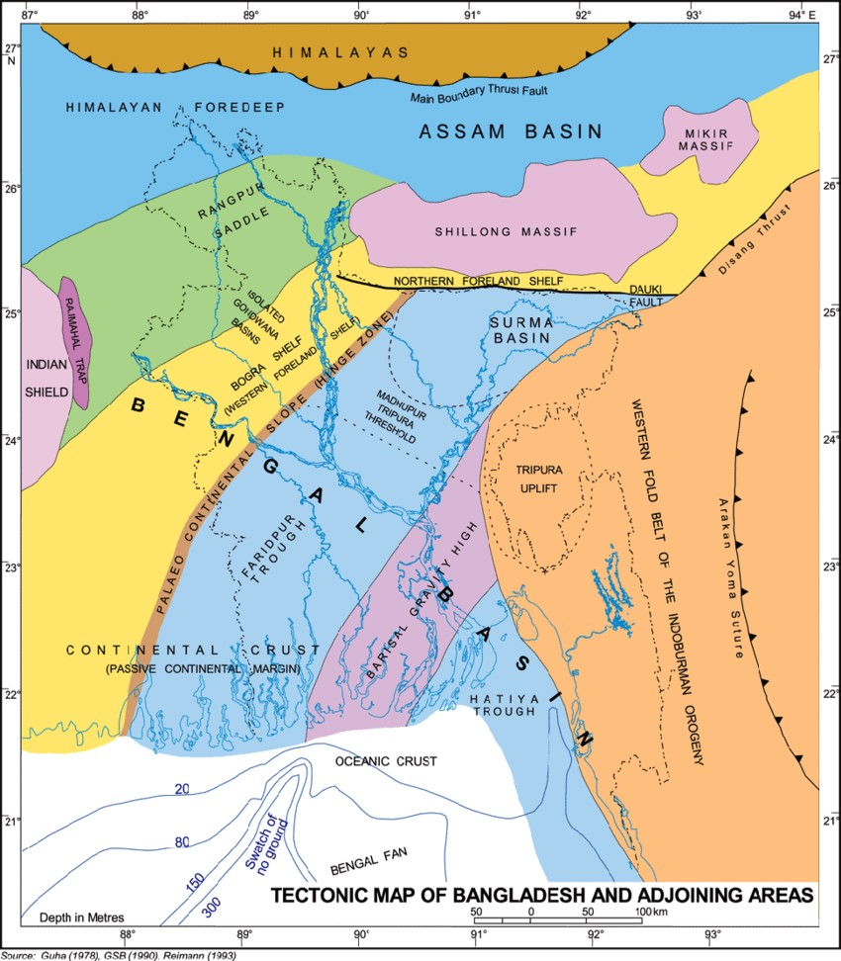
Figure 2.8 Tectonic map of Bangladesh and adjoining areas (Source: Reiman, 1993)

2.2.2 The Geologic Characteristics of the Study Area
The research area is situated on the Rangpur platform, a stable section of the Bengal Basin that is bounded to the south by the Bogra shelf, to the west by the Rajmahal trap, and to the north by the Himalayan foredeep. It is a component of the Nawabganj-Gaibandha intracratonic structure, a depression formed by the rise of the Barind Tract along the eastern side, according to Khan and Rahman (1992). This region is characterised by a thick layer of sediments from the Cretaceous to the present that cover the Archean basement. Quaternary strata ranging in thickness from 65 to 111 meters overlay the Eocene-aged Tura sandstone

Table 2.4 General Stratigraphy of the study area: Generalized stratigraphic succession of the north western part of Bangladesh (after Zaher and Rahman, 1980)
Period | Epoch | Formation | Lithologic Description | Depth (m)
Quaternary | Recent to Sub- Resent | Alluvium | Sand, Silt and Clay | 78
 | Pleistocene | Barind Clay | Clay, sandy clay, yellow brown sticky | 15
Tertiary | Middle Pliocene to Late Miocene | Dupi Tila | Sandstone with subordinate pebble bed, grit bed and shale | 276
 | Early Miocene | Jamalganj | Fine to medium grained sandstone, sandy and silty shale, silty shale, siltstone, shale. | 413
 | Oligocene | Bogra Formation | Siltstone, carbonaceous shale and grained sandstone. | 163
 | Late Eocene | Kopili formation | Sandstone locally glauconitic and highly fossiliferous. Shale with the calcareous bands. | 43
 | Middle Eocene to Late Eocene | Sylhet Limestone Formation | Nummulitic limestone with sandstone interbeds | 494
 | Middle Eocene | Tura Sandstone Formation | Gray and white sandstone, with subordinate, greenish grey shale and coal. | 104
Late Cretaceous |  | (SibganjFm) Trapwash | Coarse yellow brown sandstone, volcanic material, white clay | 131
Late Jurassic to Middle Cretaceous |  | Rajmahal Trap | Amygdaloidal basalt. Serpentinite shale and agglomerate. | 305
Late Permian |  | Paharpur Formation | Felspathic sandstone, shale and coal beds. | 421
 |  | Kuchma Formation | Sandstone and grit with subordinate shale interbedded with coal beds. | 494
Pre-Cambrian |  | Basement Complex | Gneiss, schist, granodiorite, quartz diorite | Basement not found

2.2.3 Stratigraphy of the study area
The floodplain is part of the study area, which extends northward into Bangladesh. It is situated on the Rangpur Saddle's Bogra slope in the Bengal Basin. Alluvial sand, silt, and clay make form the sedimentary strata that make up the majority of the surface geology. These strata are primarily riverine in origin. This area is under the Quaternary alluvial sequence and is classified as a portion of the Ganges floodplain.
The quaternary sediments in Bangladesh are significant aquifers; studies by McArthur et al. (2001) and BGS and DPHE (2001) demonstrate that arsenic enrichment in the Holocene alluvial aquifers is primarily limited to shallow and moderate depths. Since 2000, Acharyya et al. from West Bengal, India, have found similar findings. These sediments are mostly composed of sands, silts, and clays. According to Goodbred and Kuehl (2000), the primary causes of Quaternary sedimentation in the Bengal Basin include sea level fluctuations, active tectonic activity, and large-scale sediment supply (Table 2.5). gives a brief overview of the arsenic content of the sediments and the Quaternary stratigraphy of Bangladesh.

Table 2.5: Bangladesh's Quaternary stratigraphy in general and As status (K.M. Ahmed et al.)
Age | Formation | Lithology | Arsenic status
Holocene | Alluvium | It contains fine sand, silt, grey clay, and occasionally peat and gravel. | greater in peaty, finer layers and lower in gravelly, coarser layers. Oxalate can be used to remove most of the As..
Pleistocene | Madhupur Clay | mottled reddish brown silt and clay | minimal, unrecoverable from oxalate
Plio-Pleistocene | DupiTila | Fine to medium-sized yellowish-brown sand | Very low

2.3 Hydrogeology
As status and Quaternary stratigraphy in general, according to Ahmed (2003). The Tista fan is located in Zone 1; floodplains are located in Zones 2 and 3; the Sylhet depression is located in Zone 4; the Coastal Plains are located in Zone 5; and Complex Geology Areas are located in Zone 6. The Chapai Nawabganj municipality, as well as the Baroghoria, Baliadanga, and Maharahpur Unions within Chapai Nawabganj Sadar Upazila, Chapai Nawabganj District, are included in Zone-2 (Flood Plains). Recent alluvial deposits make up the majority of the materials found in these flood plain deposits.

CHAPTER THREE
METHODOLOGY
.

3.1 Study Area Selection
The Mahananda Floodplain was selected as the study area because groundwater is the main source of drinking and irrigation water, and previous studies have reported elevated arsenic concentrations in this region. The area consists mainly of young alluvial sediments deposited by the Mahananda River and its tributaries. These sediments contain sand, silt, clay, iron minerals, and organic matter, which may influence arsenic release into groundwater.
The geographical boundary of the study area was delineated using satellite images, topographic maps, and GIS tools. Information on geology, geomorphology, hydrology, land use, and groundwater conditions was collected from published literature and government reports.

3.2 Groundwater Sampling
Groundwater samples were collected from 21 tube wells distributed throughout the study area to represent different hydrogeological conditions.
Before sample collection, each tube well was pumped for 5–10 minutes to remove stagnant water from the pipes. The geographical coordinates of each sampling location were recorded using a handheld GPS device.
Water samples were collected in clean polyethylene bottles. Bottles used for metal analysis were washed with dilute nitric acid and rinsed with distilled water before use. After collection, samples were preserved with nitric acid (HNO₃) and stored at low temperature until laboratory analysis.
Field observations such as well depth, water color, odor, surrounding land use, and local geological conditions were also recorded.

3.3 Physicochemical and Chemical Analysis
The collected groundwater samples were analyzed to determine their physicochemical characteristics and chemical composition.

Field Parameters
The following parameters were measured directly in the field:
- pH
- Electrical Conductivity (EC)
- Total Dissolved Solids (TDS)
- Dissolved Oxygen (DO)
- Oxidation-Reduction Potential (ORP)
- Temperature
These parameters provide important information about groundwater quality and geochemical conditions.
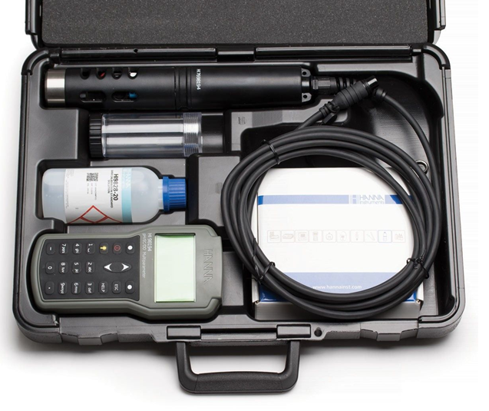

Laboratory Analysis
Major trace elements were analyzed in the laboratory.

Major Cations
- Calcium (Ca²⁺)
- Magnesium (Mg²⁺)
- Sodium (Na⁺)
- Potassium (K⁺)

Major Anions
- Bicarbonate (HCO₃⁻)
- Chloride (Cl⁻)
- Sulfate (SO₄²⁻)
- Nitrate (NO₃⁻)

Trace Elements
- Arsenic (As)
- Iron (Fe)
- Manganese (Mn)
- Other trace metals if available
Arsenic concentration was determined using ICP-MS or Atomic Absorption Spectrophotometry (AAS), which provide accurate measurements at very low concentrations.
Quality control procedures including blanks, duplicate samples, calibration standards, and certified reference materials were used to ensure analytical accuracy.
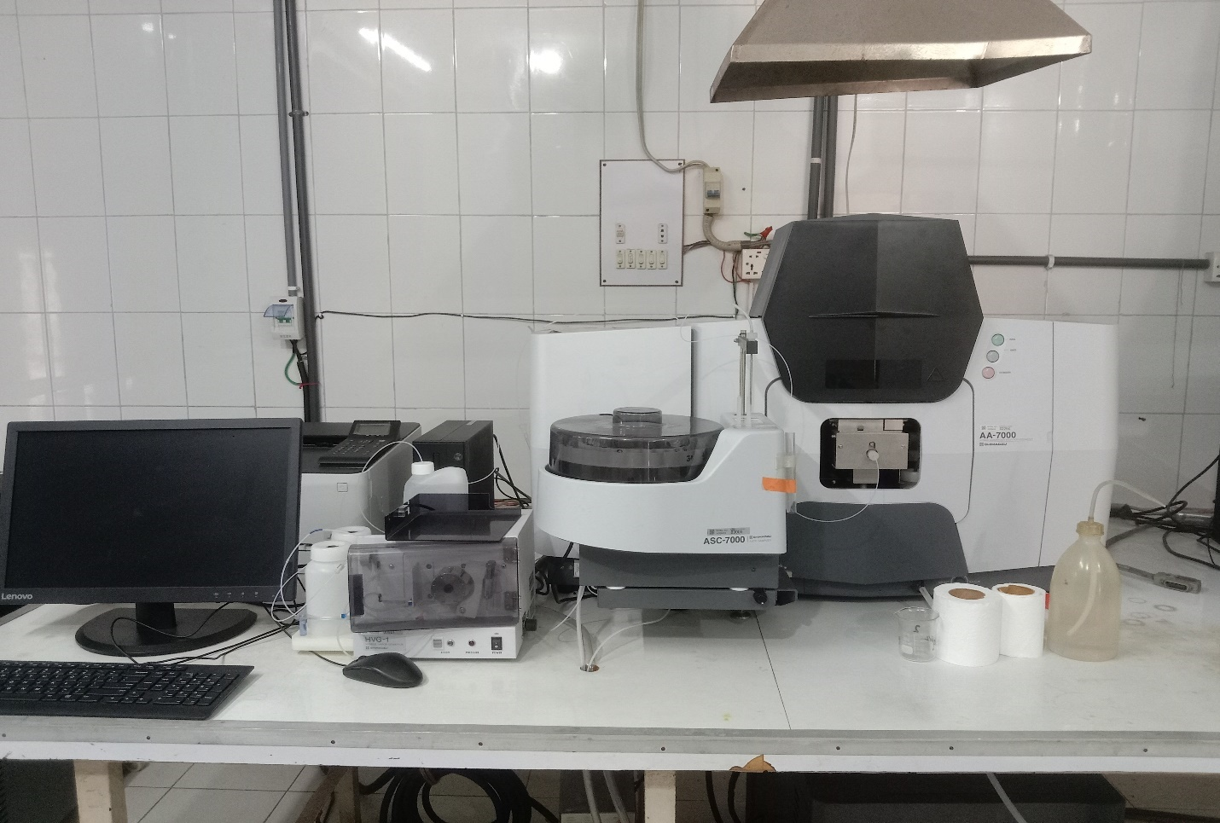

3.4 Spatial Distribution Mapping of Arsenic
The spatial distribution of arsenic was evaluated using Geographic Information System (GIS) techniques.
The sampling locations and arsenic concentrations were entered into ArcGIS software. An Inverse Distance Weighting (IDW) interpolation method was applied to estimate arsenic concentrations in unsampled locations.
The generated maps helped to:
- Identify arsenic hotspots.
- Understand spatial variation of contamination.
- Compare contaminated and less contaminated zones.
- Visualize the distribution pattern across the floodplain.
These maps provide a clear picture of areas that are most vulnerable to arsenic contamination.

3.5 Hydrogeochemical Investigation of Arsenic Genesis
The genesis mechanism refers to the natural processes responsible for arsenic release into groundwater.
To investigate these processes, relationships between arsenic and other hydrochemical variables were examined.

3.5.1 Correlation Analysis
Pearson correlation analysis was used to evaluate relationships between arsenic and other parameters.
Positive correlations between arsenic and iron, manganese, bicarbonate, or reducing conditions may indicate reductive dissolution processes.
Negative correlations with dissolved oxygen or oxidation potential may suggest reducing environments favorable for arsenic release.

3.5.2 Principal Component Analysis (PCA)
PCA was used to reduce the complexity of the dataset and identify major geochemical processes controlling groundwater chemistry.
Variables grouped within the same principal component were interpreted as being influenced by similar geochemical processes.
For example:
- Arsenic associated with Fe, Mn, and HCO₃⁻ may indicate reductive dissolution.
- Arsenic associated with pH may indicate desorption under alkaline conditions.

3.5.3 Geochemical Interpretation
The statistical results were interpreted to test different arsenic release mechanisms, including:

3.5.6 Reductive Dissolution
Iron oxyhydroxides present in sediments can adsorb arsenic. Under oxygen-poor conditions, these iron minerals dissolve and release arsenic into groundwater.

3.5.7 Alkaline Desorption
High pH conditions may reduce the adsorption capacity of mineral surfaces, causing arsenic to be released into groundwater.

3.5.8 Oxidation of Arsenic-Bearing Minerals
Oxidation of sulfide minerals such as arsenopyrite can release arsenic into groundwater.

3.5.9 Organic Matter Decomposition
Organic matter can consume oxygen and create reducing conditions that favor arsenic mobilization.

3.6 Source Identification Using Statistical Modeling

3.6.1 Factor Analysis (FA)
Factor Analysis was applied to identify hidden factors controlling groundwater chemistry.
Factors with Eigenvalues greater than one were extracted.
The factor loadings helped identify possible contamination sources such as:
- Natural geochemical processes.
- Sediment-water interactions.
- Agricultural activities.
- Anthropogenic influences.

3.6.2 Hierarchical Cluster Analysis (HCA)
Cluster Analysis grouped groundwater samples based on their chemical similarity.
Ward's linkage method and Euclidean distance were used to construct dendrograms.
The clusters helped:
- Classify groundwater types.
- Identify arsenic-contaminated zones.
- Differentiate natural and anthropogenic influences.

3.7 Human Health Risk Assessment
Human health risks associated with arsenic-contaminated groundwater were evaluated following United States Environmental Protection Agency (USEPA) guidelines.

3.7.1 Non-Carcinogenic Risk
The Average Daily Dose (ADD) was calculated using:
ADD = (C × IR × EF × ED) / (BW × AT)
where:
- C = arsenic concentration
- IR = ingestion rate
- EF = exposure frequency
- ED = exposure duration
- BW = body weight
- AT = averaging time
The Hazard Quotient (HQ) was determined as:
HQ = ADD / RfD
The Hazard Index (HI) was calculated to evaluate overall non-carcinogenic health risk.

3.7.2 Carcinogenic Risk
Cancer Risk (CR) was estimated using:
CR = ADD × CSF
where CSF represents the cancer slope factor for arsenic.
Risk values were compared with USEPA acceptable limits to determine potential health impacts.

3.8 Monte Carlo Uncertainty Analysis
A Monte Carlo simulation with 10,000 iterations was conducted to evaluate uncertainty in health risk estimates.
Instead of using a single value for each exposure parameter, probability distributions were assigned to variables such as:
- Arsenic concentration
- Water intake rate
- Body weight
- Exposure duration
The simulation generated thousands of possible risk scenarios and provided:
- Mean risk values
- Confidence intervals
- Probability distributions
- 95th percentile risk estimates
This approach improves the reliability of the health risk assessment.

3.9 Mitigation and Management Strategies
Based on the spatial distribution, hydrogeochemical interpretation, and health risk assessment results, suitable mitigation measures were proposed. These include:
- Regular groundwater quality monitoring.
- Installation of arsenic removal technologies.
- Identification and protection of safe aquifers.
- Promotion of alternative water sources.
- Community awareness and public health programs.
- Development of groundwater management policies for sustainable water use.

3.10 Data Analysis Software
The following software packages were used:
- ArcGIS 10.x for spatial analysis and mapping.
- IBM SPSS Statistics for PCA, Factor Analysis, and Cluster Analysis.
- Microsoft Excel and OriginPro for data processing and visualization.
- Python/R for Monte Carlo simulation and uncertainty analysis.
- AquaChem for hydrochemical interpretation where applicable.
A Monte Carlo simulation with 10,000 iterations was conducted to evaluate uncertainty in health risk estimates.
Instead of using a single value for each exposure parameter, probability distributions were assigned to variables such as:
- Arsenic concentration
- Water intake rate
- Body weight
- Exposure duration
The simulation generated thousands of possible risk scenarios and provided:
- Mean risk values
- Confidence intervals
- Probability distributions
- 95th percentile risk estimates
This approach improves the reliability of the health risk assessment.

Flow Chart of Methodology
Literature Review & Study Area Selection
│
▼
Groundwater Sample Collection
│
▼
Field Measurement (pH, EC, TDS,
DO, ORP, Temperature)
│
▼
Laboratory Chemical Analysis
(As, Fe, Mn, Major Ions, etc.)
│
▼
Data Quality Control (QA/QC)
│
▼
Spatial Distribution Mapping
(GIS & IDW Interpolation)
│
▼
Hydrogeochemical Analysis & Genesis
(Correlation, PCA, Geochemistry)
│
▼
Source Identification
(Factor Analysis & Cluster Analysis)
│
▼
Human Health Risk Assessment
(HI, HQ, Cancer Risk)
│
▼
Monte Carlo Simulation
(Uncertainty Assessment)
│
▼
Result Interpretation
│
▼
Mitigation & Management Strategies
│
▼
Conclusions
CHAPTER FOUR
HYDROCHEMISTRY

The quality of groundwater refers to its chemical, physical, and biological properties, which determine its suitability for various purposes like as agriculture and domestic purposes. It involves assessing parameters like pH, contaminants, and microbial content to ensure it meets drinking water standards and supports ecosystem health which are discussed in this chapter.

4.1 Groundwater Physical Properties
Concentration of hydrogen ions (pH): One of the most important measurements of water's acidity, neutrality, or alkalinity is its pH. The pH scale goes from 7.0 for a neutral solution to less than 7 for acidic solutions and more than 7 for alkaline solutions. The average pH in the research area is 7.3005, with a range of 7.16 to 7.4 .
Specific Electrical Conductance (EC): Electrical conductance measures the abundance of charged ionic species, with higher EC values reflecting higher ionic concentrations and lower EC values indicating lower ionic concentrations. Regarding the International System of Units (SI), the unit of conductivity is the Siemens. Very pure water has a conductance of about 0.05 mho/cm, although even demineralized or distilled water usually has a conductance of at least 1.0 µmho/cm. As demonstrated by seawater, conductivity can surpass 50,000 µS/cm in some locations (Hens, 1985). Total Dissolved Solids (TDS) in water can be usefully indicated by the EC value. The average EC in the studied region is 1218.05 µS/cm, with a range of 940 to 1732 µS/cm
Total Dissolved Solids (TDS): Groundwater's total dissolved solids (TDS) are an important physical feature. TDS is usually mainly discussed in relation to freshwater systems since salinity includes some of the ions that make up TDS. TDS is mostly used to assess the water quality of rivers, lakes, and streams. The average TDS value in the research area is 608.85 ppm, with a range of 471 to 867 ppm
Oxidation Reduction Potential (ORP): ORP (Oxidation-Reduction Potential) is vital for assessing groundwater quality. It indicates the water's oxidizing or reducing potential, crucial for freshwater systems' health. High ORP implies oxidation, while low values suggest reduction.

4.2 Classification Using Water Use Standards
4.4.2.1 Standards for Drinking Water Quality
Water quality is an important factor to take into account because it has to meet internationally accepted criteria for drinking. Public health groups have proposed these norms, which include a range of requirements to guarantee the safe use of water in homes. Table 4.5 presents an evaluation and alignment of the groundwater quality in the research region with the drinking water criteria set by Bangladeshi authorities and the World Health Organization (WHO).

Table 4.5 Evaluation of the study area's groundwater quality in relation to WHO standards.

Metal Element | Mean (ppb) | Median (ppb) | Max Value (ppb) | WHO Guideline Exceedance (µg/L) | Histogram Distribution Shape
As_75 | 35.45 | 6.59 | 283.57 | 10 | Highly right-skewed; single outlier sample >200 ppb
Se_82 | 0.80 | 0.75 | 1.56 | 40 | Uniformly safe; tight clustering well below the guideline line
Pb_208 | 8.80 | 4.05 | 85.80 | 10 | Heavily right-skewed; single critical location near 100 ppb
Cd_111 | 0.14 | 0.06 | 1.26 | 3 | Bulk of concentrations fall safely under the 3.0 ppb limit
Cr_52 | 2.14 | 2.18 | 3.05 | 50 | Symmetrical normal-like peak well below the safety mark
Ni_60 | 9.25 | 9.50 | 13.05 | 70 | Safe, tightly bounded distribution
Cu_63 | 3.99 | 3.57 | 10.33 | 2000 | Safe; standard unimodal curve
Zn_66 | 60.57 | 38.25 | 289.51 | 3000 | Safe; minor clustering towards lower limits
Hg_202 | 0.18 | 0.16 | 0.38 | 6 | Safe; localized distribution below the 6.0 ppb guideline
Co_59 | 0.83 | 0.85 | 1.57 | No Guideline | Roughly bimodal distribution across narrow limits
Be_9 | 0.01 | 0.01 | 0.05 | 12 | Concentrated entirely around background levels
V_51 | 3.03 | 1.74 | 8.87 | No Guideline | Broad, irregular shape spanning 0.4 to 10 ppb
Fe_57 | 2851.72 | 1439.70 | 17364.93 | 300 | Critical compliance failure; almost all samples fail line
Mn_55 | 740.83 | 788.37 | 1475.80 | 400 | Severe widespread contamination; heavily shifted right

4.5 Graphical Comparison of Arsenic, Iron, and Manganese Concentrations Against WHO and Bangladesh Domestic Water Quality Standards

The figures presented show graphical depictions of groundwater samples and highlight instances in which the concentrations of iron, manganese, and arsenic are higher than the domestic water quality standards in Bangladesh as well as the World Health Organization's (WHO) Guidelines for Drinking Water Quality (GDWQ).
In Figure 4.2 (a) Eleven samples surpass both the WHO and DOE limits; two samples are permitted; other samples meet the DOE limit but surpass the WHO limit; these samples fall outside Bangladesh's domestic water quality standard range of 0.3-1 mg/L and exceed the WHO guideline for drinking water quality (GDWQ) of 0.3 mg/L.
Figure 4.2 (b) Shows the amounts of manganese in twenty groundwater samples, all of which are higher than the 0.1 mg/L household water quality level in Bangladesh and the 0.5 mg/L WHO Guideline for Drinking Water Quality (GDWQ) standard.
Furthermore, in Figure 4.2 (c), twelve samples display arsenic concentrations surpassing the WHO and DOE Guideline for Drinking Water Quality (GDWQ) value of 10 µg/L, while one sample exceeds WHO limit but within DOE limit and other samples within permissible limits.

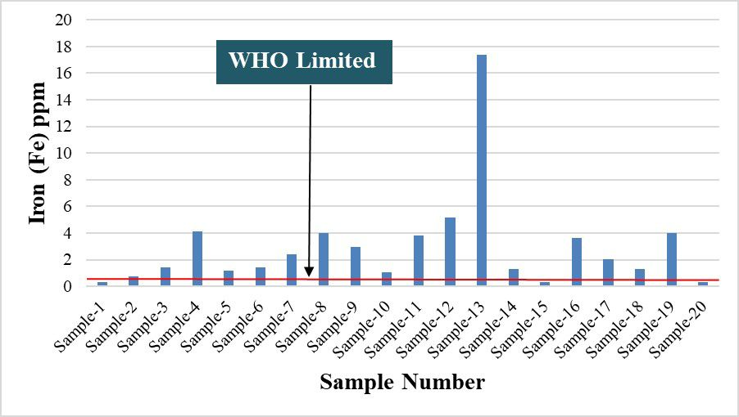
(a)

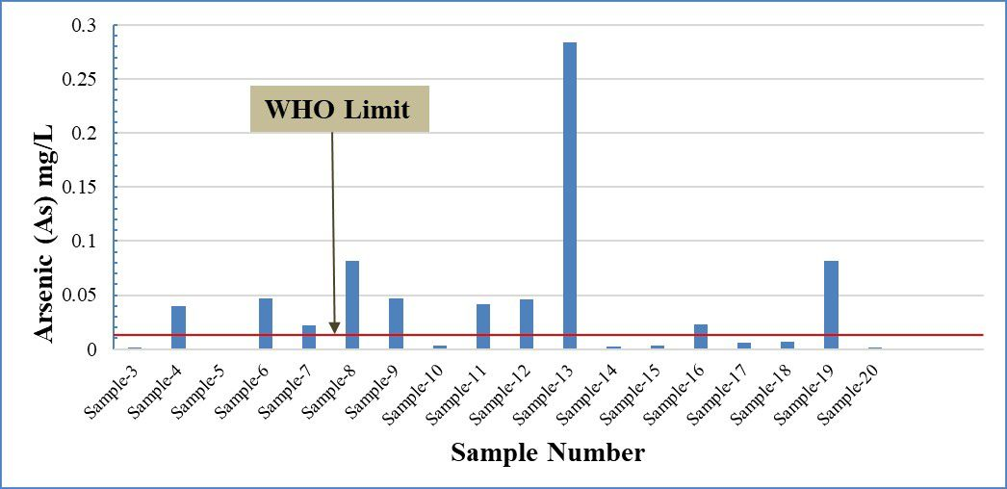
(b)
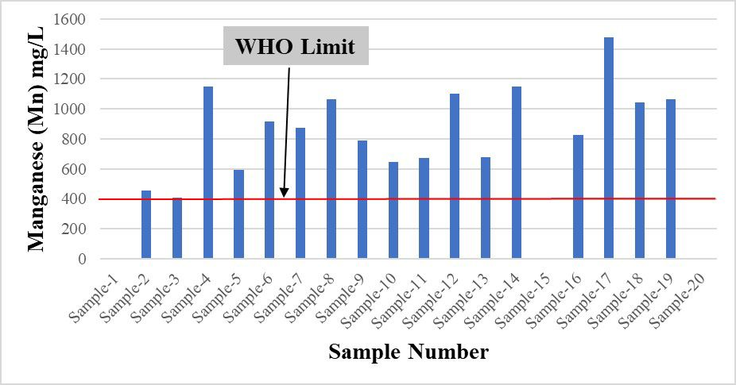
(c)
Figure 4.2 The distribution of contamination levels for (a) Fe, (b) Mn, and (c) As in the groundwater samples.

4.6 Variation in Arsenic, Iron, and Manganese Concentrations Across Groundwater Samples

4.6.1 Distribution of Arsenic (As)
Arsenic (As) concentrations in groundwater of Chapai Nawabganj Municipality, Baragharia, and Maharajpur, Ranihati, and Baliadanga Unions within Chapai Nawabganj Sadar Upazila are plotted on the map in Figure 4.3.
The histogram of arsenic (As) concentrations in 21 groundwater samples reveals considerable variability in groundwater quality, with concentrations ranging from less than 1 ppb to more than 200 ppb on a logarithmic scale in Figure 4.4. The distribution is positively skewed, characterized by a small number of highly contaminated samples that extend the upper tail and significantly increase the mean concentration (approximately 30–35 ppb) above both the median value (approximately 6–7 ppb) and the WHO drinking-water guideline of 10 ppb. This disparity between the mean and median indicates the strong influence of a few extreme arsenic concentrations on the overall dataset. The histogram also suggests a bimodal distribution, with one cluster of samples occurring below 10 ppb and another between approximately 20 and 80 ppb, which may reflect differences in hydrogeochemical conditions or arsenic mobilization mechanisms within the aquifer system. Several samples exceed the 10 ppb guideline, while some contain arsenic concentrations greater than 100 ppb, indicating severe localized contamination and potential health risks for consumers. Such elevated concentrations are likely associated with geogenic processes, including the dissolution of arsenic-bearing minerals and the reductive dissolution of iron oxides. Overall, the wide range and spatial variability of arsenic concentrations emphasize the importance of continuous groundwater monitoring, identification of contamination sources, and implementation of appropriate mitigation strategies to ensure safe drinking-water supplies.
With a value of 7500 µg/L, sample location GW-12, which is located in the southeast of Rajarampur (Bangdubipara) under Chapai Nawabganj Municipality, appears to have the highest arsenic content. On the other hand, sampling locations GW-1, GW-2, GW-3, and GW-4 in the northwest of Baliadanga Union within the study region had the lowest arsenic levels, at 1.0 µg/L.

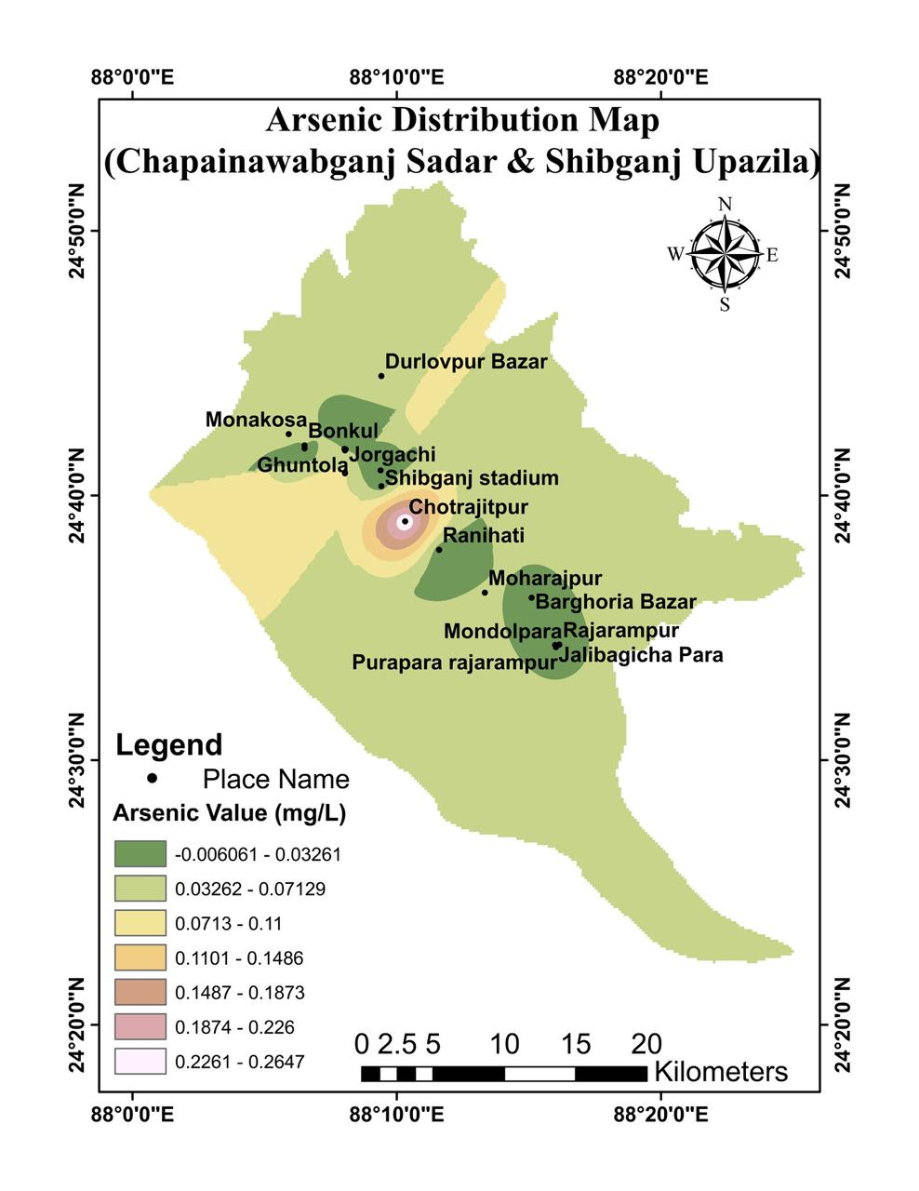
Figure 4.3 Diagram illustrating the distribution of arsenic (As) concentration in mg/L in the rajarampur,Jorgachi,Monakosa,Shibganj stadium’ Baragharia, Maharajpur, Ranihati, and Baliadanga unions within the Chapai Nawabganj Sadar & Shibganj Upazila, located in the northwest region of Bangladesh.
Figure4.4: Distribution map of arsenic in Groundwater.

4.6.2 Distribution of Iron (Fe)
The iron (Fe) distribution map Figure4.5 and histogram Figure4.6 provide a comprehensive overview of groundwater iron concentrations in Chapainawabganj Sadar and Shibganj Upazila based on 21 sampled locations. The spatial distribution map reveals that iron concentrations vary considerably across the study area, ranging from 0.3883 to 17.05 mg/L. Most locations are characterized by moderate iron concentrations (approximately 2.77–9.91 mg/L), while a distinct hotspot of elevated iron levels occurs around the Chotrajitpur–Shibganj Stadium area, where concentrations exceed 14.68 mg/L. The contour pattern indicates localized enrichment of iron, suggesting the influence of specific hydrogeochemical conditions or geogenic sources. The accompanying histogram shows that iron concentrations range from about 200 ppb to more than 15,000 ppb and display a positively skewed distribution. The mean concentration (blue line; ~3,000 ppb) is substantially higher than the median concentration (black dotted line; ~1,500–2,000 ppb), indicating that a few highly enriched samples strongly influence the dataset. The red dashed line represents the WHO drinking-water guideline value of 300 ppb, and most samples exceed this threshold, demonstrating widespread iron contamination in groundwater. Overall, both the spatial and statistical analyses indicate significant variability in iron concentrations, with localized zones of severe enrichment and a large proportion of groundwater samples unsuitable for direct consumption without treatment. These findings highlight the need for continuous monitoring and appropriate water treatment measures to ensure safe drinking-water quality in the study area.
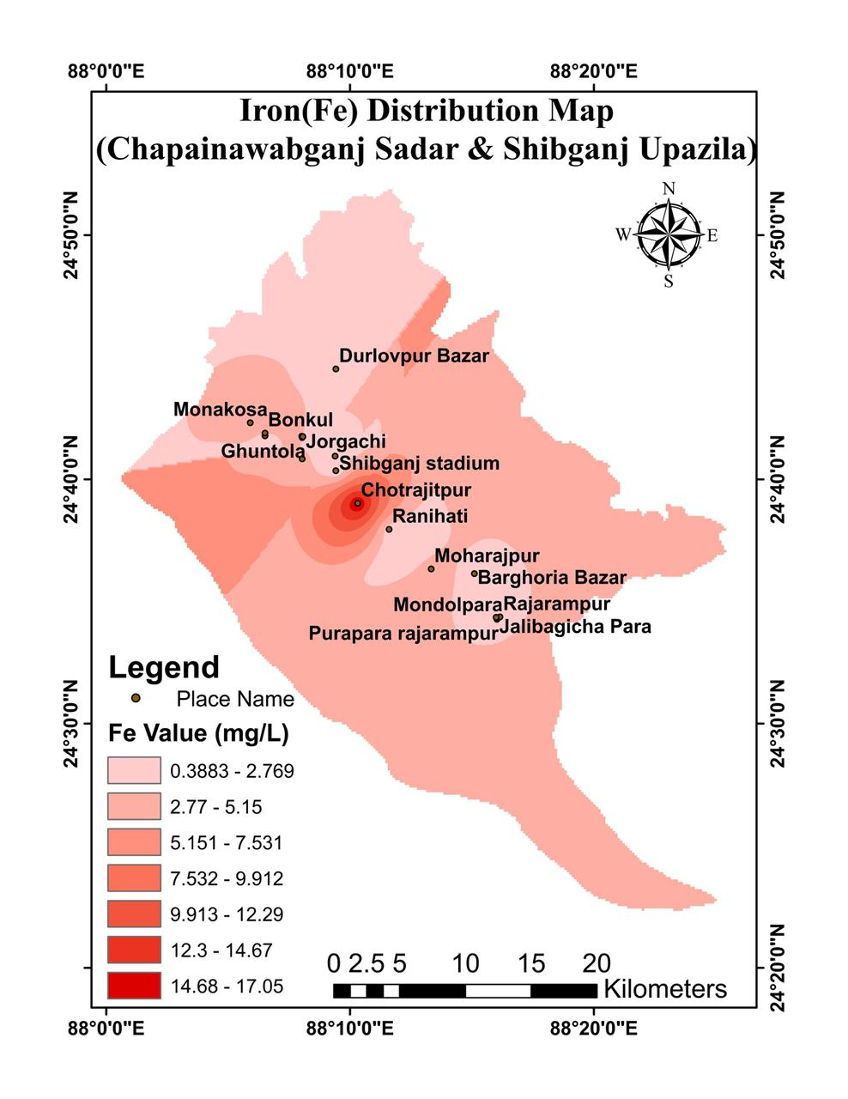
Figure 4.5 Graph illustrating the distribution of iron (Fe) concentration in milligrams per liter for the Chapai Nawabganj sadar & Shibganj upazila Rajarampur, Baragharia, Maharajpur, Ranihati, and Baliadanga unions in the northwest region of Bangladesh (Chapai Nawabganj Sadar Upazila).

Figure4.6: Distribution map of Iron(Fe) in Groundwater.

4.6.3 The Distribution of Manganese (Mn)
The manganese (Mn) distribution map illustrates the spatial variation of manganese concentrations in groundwater across Chapainawabganj Sadar and Shibganj Upazila. Manganese concentrations range from approximately 586.8 to 873.5 ppb, indicating moderate variability throughout the study area. Higher manganese concentrations (791.7–873.5 ppb), represented by darker green shades, are predominantly observed in the northwestern and northern parts of the study area, particularly around Monakosa, Bonkul, Ghuntola, and Durlovpur Bazar. In contrast, lower concentrations (586.8–668.7 ppb), shown by lighter green shades, are mainly distributed in the eastern and southeastern regions, including areas near Rajarampur, Jalibagicha Para, and the southern extension of the study area. The gradual transition from higher concentrations in the northwest to lower concentrations in the southeast suggests a spatial trend that may be controlled by local hydrogeological conditions, groundwater flow patterns, sediment composition, or geochemical processes. Overall, the map indicates that manganese is widely distributed throughout the aquifer system, with distinct zones of enrichment and depletion reflecting variations in groundwater chemistry and subsurface geological environments.
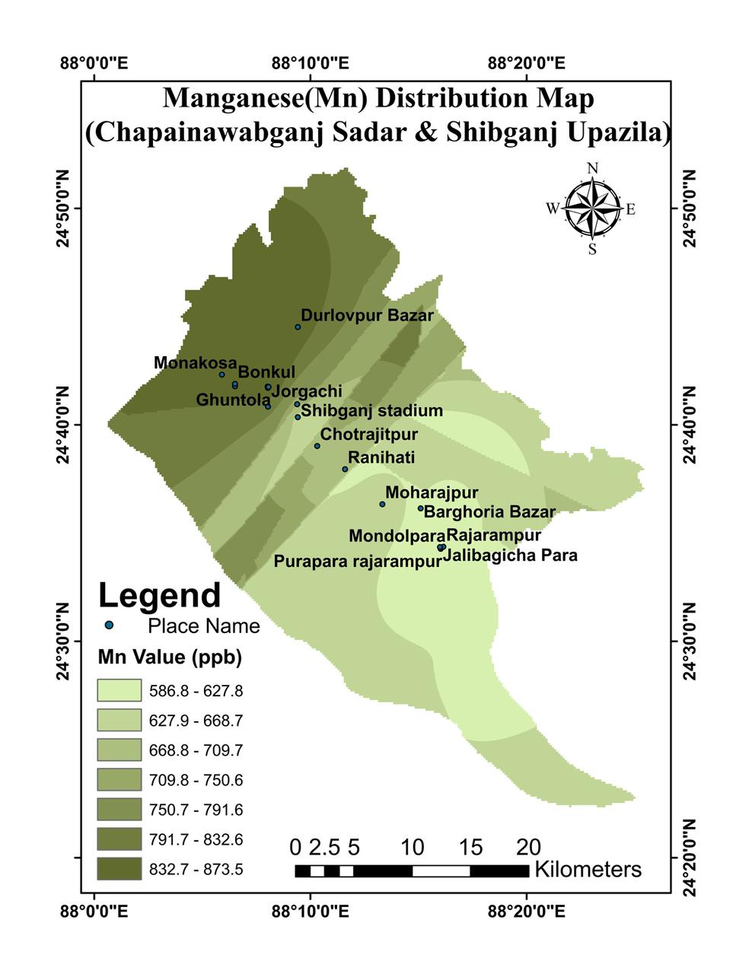
Figure 4.7 The manganese content distribution in milligrams per liter is displayed on a map in the northwest region of Bangladesh, specifically in the Chapai Nawabganj Sadar Upazila, Baragharia, Maharajpur, Ranihati, and Baliadanga unions.

Figure4.8: Distribution map of Manganese(Mn) in Groundwater.

4.7 Interpretation of Heavy Metal Correlation Matrix with Hierarchical Clustering

The figure presents a Pearson correlation matrix of heavy metal concentrations in groundwater samples, integrated with hierarchical clustering to identify statistically coherent geochemical groupings. The correlation coefficients range from strongly negative (blue) to strongly positive (red), indicating the degree of linear association among the analyzed metals. The accompanying dendrogram further classifies the variables into distinct clusters based on similarity patterns, providing insight into potential common sources and geochemical behavior.

4.7.1. Major Positive Correlation Groups (Common Source Indicators)
A very strong positive correlation is observed among Pb–Cd–Be, with coefficients reaching up to 0.99, indicating a highly consistent co-occurrence. This cluster suggests a likely shared anthropogenic origin, such as industrial discharge, battery waste, or urban runoff. Similarly, As and Fe show an exceptionally strong correlation (r ≈ 0.97), implying a strong geogenic control, where arsenic mobility is closely linked to iron oxyhydroxide dissolution under reducing groundwater conditions.
Another distinct cluster includes Cu, Se, and V, which also show moderate to strong positive correlations (e.g., Cu–V ≈ 0.74, Se–V ≈ 0.83). This grouping suggests mixed geogenic–anthropogenic influence, potentially associated with mineral weathering and agricultural inputs (e.g., phosphate fertilizers and trace metal-rich sediments).

4.7.2. Moderate Association Cluster (Transition Group)
Metals such as Zn, Mn, Ni, and Co exhibit moderate inter-element correlations. In particular, Ni–Co (r ≈ 0.83) and Mn–Ni (r ≈ 0.62) indicate a shared lithological source, likely derived from mafic/ultramafic mineral weathering or sediment–water interaction processes. These elements also show weaker or negative relationships with the Pb–Cd group, suggesting distinct geochemical pathways.

4.4.3. Negative Correlation Structure (Antagonistic Behavior)
A pronounced negative correlation is observed between the As–Fe cluster and Mn/Ni/Co group, with values reaching as low as r ≈ −0.64. This inverse relationship suggests redox-controlled geochemical partitioning, where iron reduction enhances arsenic release, while manganese and nickel may remain stable or behave independently under varying oxidation–reduction conditions.

4.7.4. Hierarchical Clustering Interpretation
The dendrogram clearly separates the variables into three major geochemical assemblages:
- Anthropogenic/contaminant cluster: Pb, Cd, Be
- Redox-controlled geogenic cluster: As, Fe
- Lithogenic/transition cluster: Mn, Ni, Co, Zn, Cu, Se, V
This clustering structure confirms that groundwater contamination is not random but governed by distinct geochemical processes including industrial influence, mineral weathering, and redox-driven mobilization.

4.7.5. Environmental Significance
The coexistence of strong anthropogenic and geogenic clusters suggests a dual contamination mechanism, where natural geological processes are being compounded by human activities. Of particular concern is the As–Fe association, which indicates potential arsenic mobilization under reducing aquifer conditions, posing a significant risk to drinking water safety.

4.8 Correlation Matrix & Hierarchical Clustering

The integrated statistical analysis of groundwater heavy metals reveals clear patterns of contamination and geochemical relationships among the studied elements. Correlation and clustering analyses indicate that Mn, Ni, and Co are strongly associated, suggesting a common source or similar geochemical behavior, while Cu, Se, and V form another closely related group. The concentration distribution shows that Fe and Mn are the most abundant metals in the groundwater, whereas Be occurs at very low levels.
The frequency distribution analysis indicates that arsenic (As), iron (Fe), manganese (Mn), and lead (Pb) are the main contaminants of concern. Among these, Fe and Mn exceed the WHO guideline values in most samples, while nearly half of the samples contain arsenic concentrations above the recommended limit. In contrast, Se, Cd, Cr, Ni, Cu, Zn, and Hg remain within acceptable safety limits.
4.8.1 Principal Component Analysis (PCA) : PCA explains 66.34% of the total variation in groundwater chemistry and identifies Fe, Mn, and As as the major factors controlling contamination patterns. Hierarchical clustering further classifies the 21 groundwater samples into five groups, ranging from relatively low-contamination sites to highly polluted hotspots. Sample 13 represents the most severely contaminated location with exceptionally high Fe, Mn, and As concentrations, while Sample 21 is distinguished by elevated Pb levels. Overall, the results suggest that groundwater quality is strongly influenced by both natural geochemical processes and localized contamination sources, with arsenic, iron, and manganese being the primary concerns for groundwater safety.

4.9 Principal Component Analysis (PCA) and Sensitivity Analysis Interpretation
The PCA biplot was used to identify the major factors controlling groundwater chemistry and arsenic distribution. The first two principal components (PC1 and PC2) explained 51.78% of the total variance in the dataset, indicating that they captured most of the geochemical variability.
Arsenic (As), iron (Fe), and manganese (Mn) showed a strong positive association and were grouped closely together in the PCA biplot. This relationship suggests that arsenic release into groundwater is mainly controlled by the reductive dissolution of iron and manganese oxides under reducing aquifer conditions. Sample 13 was located near the As–Fe–Mn cluster, indicating that it represents the major arsenic contamination hotspot within the study area.
In contrast, vanadium (V), selenium (Se), and copper (Cu) formed a separate cluster, suggesting that these elements are controlled by different geochemical processes. Lead (Pb), cadmium (Cd), and beryllium (Be) also formed an independent group, indicating possible localized contamination sources distinct from the arsenic mobilization mechanism.
The Global Sensitivity Analysis further demonstrated strong interactions among groundwater constituents. Vanadium (V) was identified as the most influential variable in the dataset, followed by chromium (Cr) and copper (Cu). A strong mutual sensitivity was observed between arsenic and iron, confirming that arsenic behavior is closely linked to iron mineral dissolution processes. These findings support the conclusion that geogenic processes, particularly iron oxide reduction, play a dominant role in controlling arsenic contamination in the groundwater system.

4.10 Quartile Distribution of Heavy Metal Concentrations
The box-and-whisker plot shows how the concentrations of 14 heavy metals are distributed in groundwater samples. It uses a logarithmic scale, which helps compare elements that occur in very high amounts (like iron) with those found in very small traces (like beryllium). Each box represents the middle 50% of the data, the line inside shows the median value, whiskers show the overall range, and red dots represent unusual or extreme values (outliers).
Overall, the plot clearly shows that iron (Fe) and manganese (Mn) are the dominant elements in the groundwater system. Iron has the highest concentration among all elements, with consistently elevated values across samples, indicating strong natural enrichment or possible geochemical mobilization from sediments. Manganese also shows very high levels, though slightly lower than iron, suggesting similar geochemical behavior and a shared source or controlling process.
Arsenic (As) is particularly important because it shows a very wide spread of values. This means arsenic concentration is highly variable from one location to another. Some samples contain very low levels, while others show very high contamination. This pattern suggests that arsenic is influenced by localized geochemical conditions rather than being evenly distributed in the aquifer.
Zinc (Zn) occurs at moderate levels and shows some variability, but not as extreme as arsenic. Nickel (Ni) and copper (Cu) show relatively stable distributions with narrow boxes, meaning their concentrations do not change much between samples and are more consistent across the study area.
Lead (Pb) generally remains at low to moderate levels, but the presence of a strong outlier indicates that at least one site is affected by localized lead contamination, possibly from anthropogenic sources. Chromium (Cr), cobalt (Co), and vanadium (V) appear in intermediate concentration ranges and show moderate variation, suggesting mixed natural and minor anthropogenic influence.
In contrast, cadmium (Cd), mercury (Hg), and especially beryllium (Be) are present at very low concentrations. Beryllium shows the lowest values of all elements, indicating minimal natural presence in the groundwater system.
In summary, the figure highlights a clear separation between major contaminants (Fe, Mn, As), moderate trace metals (Zn, Ni, Cu, Pb, Cr, Co, V), and ultra-trace elements (Cd, Hg, Be). The overall pattern suggests that groundwater chemistry is mainly controlled by a few dominant elements with high concentrations and variability, while most other metals remain at low and relatively stable levels across the study area.

4.11 Hierarchical Clustering Dendrogram
The hierarchical clustering dendrogram groups 21 groundwater samples based on similarities in their heavy metal concentrations. The vertical axis shows the level of difference between samples (Euclidean distance), while the horizontal axis represents the individual sampling locations. A red dashed line at distance 8.0 is used to divide the samples into separate clusters.
The results show that groundwater samples can be clearly divided into distinct contamination groups. Two samples stand out as strong outliers. Sample 13 separates very early from all other samples, showing a unique and extreme contamination pattern dominated by high levels of multiple metals, especially arsenic, iron, and manganese. This indicates that Sample 13 represents a highly polluted hotspot in the aquifer. Similarly, Sample 21 forms its own separate branch, mainly due to unusually high lead (Pb) concentration, suggesting a localized source of contamination.
The remaining samples form three main groups with more similar chemical characteristics. One cluster includes samples with generally elevated iron and manganese levels, indicating moderately impacted groundwater influenced by natural geochemical processes. Another larger cluster represents samples with relatively moderate and balanced metal concentrations, suggesting more uniform groundwater quality across these locations. The final small group includes samples with the lowest contamination levels, indicating relatively clean groundwater conditions and background geochemical levels.
Overall, the dendrogram shows that groundwater quality in the study area is not uniform. Instead, it consists of a mix of clean, moderately affected, and highly contaminated zones. The clustering clearly highlights that a few locations (especially Sample 13 and Sample 21) are responsible for extreme pollution conditions, while most samples share similar moderate geochemical characteristics.

4.12 Quantile Regression of Heavy Metals in Groundwater
The multi-panel quantile regression plots show how heavy metal concentrations change along the main geochemical gradient of groundwater, represented by the PC1 score. Instead of focusing only on average values (like standard regression), this method shows how metals behave at different pollution levels, from normal conditions to extreme contamination zones.
The results clearly show that groundwater chemistry does not change in a simple or uniform way. Instead, different metals respond differently depending on the level of contamination.

4.12.1. Hotspot-forming metals (Arsenic and Iron)
Arsenic and iron show a very strong increase in highly polluted areas. Their values rise slowly in normal conditions, but increase sharply in extreme conditions. This means that these two elements are closely linked and become highly concentrated in specific locations. This usually happens when underground conditions lack oxygen, causing iron minerals to break down and release arsenic into groundwater. These areas represent serious contamination hotspots.

4.12.2. Naturally controlled metals (Manganese and Chromium)
Manganese and chromium show a steady and consistent increase across all levels of groundwater conditions. Their pattern is smooth and parallel, which means their presence is controlled by natural processes such as rock weathering and long-term water–rock interaction. They are not limited to specific polluted sites but are widely distributed across the aquifer.

4.12.3. Decreasing metals (Copper, Lead, and Zinc)
Copper, lead, and zinc show a decreasing trend as groundwater conditions become more chemically active. This indicates that these metals are being reduced in concentration due to processes such as precipitation, adsorption onto soil minerals, or dilution during groundwater movement.
Mainly,the analysis shows that groundwater contamination is highly uneven across the study area. Arsenic and iron are the most dangerous pollutants and are concentrated in specific hotspots, while other metals behave in more stable or decreasing patterns. This proves that average-based analysis is not enough to understand groundwater pollution, and advanced methods like quantile regression are necessary to identify hidden contamination zones and understand real geochemical behavior where-
4.12.4 Cluster composition:
Cluster 1: 2 samples
Samples: Sample1, Sample15
Characterized by high: Fe_57(313.8), Zn_66(142.1), Pb_208(9.5)
Cluster 2: 9 samples
Samples: Sample14, Sample5, Sample3, Sample2, Sample4, Sample17, Sample18, Sample6, Sample19
Characterized by high: Fe_57(1621.7), Mn_55(869.9), Zn_66(28.9)
Cluster 3: 8 samples
Samples: Sample20, Sample11, Sample12, Sample10, Sample7, Sample8, Sample9, Sample16
Characterized by high: Fe_57(3374.2), Mn_55(880.8), Zn_66(79.2)
Cluster 4: 1 samples
Samples: Sample13
Characterized by high: Fe_57(17364.9), Mn_55(676.6), As_75(283.6)
Cluster 5: 1 samples
Samples: Sample21
Characterized by high: Fe_57(304.8), Pb_208(85.8), Zn_66(76.4)
Interpretation:
-
Samples grouped in the same cluster share similar standardized metal fingerprints.
- Cluster boundaries separate distinct contamination patterns and likely different source influences

CHAPTER FIVE

HEALTH RISK ASSESSMENT, MITIGATION AND MANAGEMENT STRATEGIES

5.1 Health Risk Assessment
The health risk assessment was conducted to evaluate the potential adverse health effects associated with long-term consumption of arsenic-contaminated groundwater in the Mahananda Floodplain. Both non-carcinogenic and carcinogenic risks were assessed for adults and children following the guidelines of the United States Environmental Protection Agency (USEPA).

5.1.1 The Integrated Pollution Index (NIPI)
The Integrated Pollution Index chart (Nemerow Pollution Index, NIPI) for 21 groundwater samples provides a comprehensive assessment of spatial variations in contamination levels and associated environmental risks across the study area. The samples are arranged in ascending order of NIPI values, enabling a clear comparison of pollution severity from least to most impacted locations. The x-axis represents the individual groundwater samples, while the y-axis indicates the corresponding NIPI values, which range from 0 to above 40. The bars are color-coded using a gradient scale, transitioning from green (low pollution) through yellow (moderate contamination) to red (severe pollution), thereby providing a clear visual representation of water quality deterioration.
The results demonstrate a pronounced heterogeneity in groundwater quality. The lowest NIPI value is observed in Sample 1 (approximately 0.8), indicating relatively clean groundwater conditions. Several samples, including Samples 15, 2, 10, 19, 5, 18, 14, 3, and 6, exhibit NIPI values between 1 and 3, suggesting low to moderate pollution levels influenced by either anthropogenic activities or natural geochemical processes. In contrast, a substantial number of samples (Samples 17, 7, 21, 9, 16, 11, 8, 20, and 4) display elevated NIPI values ranging from approximately 5 to 10, indicating heavy pollution and significant degradation of groundwater quality.
Furthermore, Sample 12 shows a markedly higher NIPI value exceeding 12, reflecting severe contamination conditions. The most critical case is observed in Sample 13, which exhibits an exceptionally high NIPI value exceeding 40, identifying it as a distinct contamination hotspot within the study area. This extreme value indicates that contaminant concentrations significantly surpass permissible limits and may pose serious environmental and public health risks if the groundwater is used without adequate treatment.

Interpretation Based on Nemerow Pollution Index Classification
NIPI Value | Pollution Level
≤ 1 | Clean / Unpolluted
1 – 2 | Slight Pollution
2 – 3 | Moderate Pollution
> 3 | Heavy Pollution
> 10 | Severe Pollution

Overall, the NIPI results highlight significant heterogeneity in groundwater quality, with a clear dominance of polluted conditions. The findings emphasize the urgent need for continuous monitoring, identification of contamination sources, and implementation of appropriate management and remediation strategies to ensure safe groundwater utilization.

5.2 Heavy Metal Pollution Index (HPI) Distribution in Groundwater
The Heavy Metal Pollution Index (HPI) results for the 21 groundwater samples provide a comprehensive evaluation of cumulative heavy metal contamination across the study area. HPI is a composite hydrochemical index that integrates the concentrations of multiple heavy metals relative to their respective guideline values, thereby offering a single quantitative measure of overall water quality deterioration due to metal pollution. The samples, arranged in ascending order of HPI values, clearly illustrate spatial variability in contamination intensity and allow for the identification of distinct hydrogeochemical zones ranging from uncontaminated to severely polluted conditions.
The graphical distribution reveals that the majority of groundwater samples exhibit low to moderate HPI values, indicating generally acceptable water quality with respect to heavy metals. Specifically, Samples 3, 10, 19, 1, 2, 17, and 14 show very low HPI values (<15), reflecting minimal anthropogenic or geogenic metal input and suggesting excellent groundwater quality. A second cluster comprising Samples 5, 18, 15, 7, and 16 displays slightly elevated HPI values (approximately 15–30), which may indicate early-stage enrichment of heavy metals; however, these values remain within acceptable limits for potable use.
A moderate deterioration in groundwater quality is observed in Samples 4, 11, 6, 9, and 12, where HPI values range between approximately 50 and 60. This range suggests increasing contributions from dissolved heavy metals, potentially influenced by localized geogenic weathering processes or anthropogenic activities such as agricultural runoff, industrial discharge, or improper waste disposal. Although these values remain below the critical threshold of 100, they indicate a progressive decline in water quality that warrants continued monitoring due to the risk of cumulative exposure.
Elevated HPI values are recorded in Samples 8 and 20 (approximately 85–90), indicating poor water quality conditions and proximity to the critical contamination limit. Sample 21, with an HPI value near 100, represents a transitional condition between poor and unsafe water quality, signifying that heavy metal concentrations are approaching levels considered unsuitable for human consumption according to international drinking-water standards.
The most critical observation is associated with Sample 13, which exhibits an exceptionally high HPI value of approximately 295. This value far exceeds both the critical threshold (HPI = 100) and the extreme contamination benchmark (HPI > 200), identifying this location as a severe heavy metal pollution hotspot. Such an anomalously high value strongly suggests intense contamination by one or more toxic metals, likely exceeding permissible limits multiple times. This condition poses a significant ecological and public health risk and indicates the probable influence of strong localized contamination sources such as industrial effluents, geogenic mineralization zones, or point-source pollution inputs.
Overall, the HPI assessment demonstrates pronounced spatial heterogeneity in groundwater quality within the study area. While the majority of samples fall within safe to moderately impacted categories, the presence of elevated and extreme HPI values in certain locations indicates localized but significant contamination. In particular, the extreme value observed in Sample 13 highlights the necessity for immediate hydrogeochemical investigation, source apportionment studies, and targeted remediation strategies. Continuous monitoring is essential to prevent further deterioration and to ensure the long-term sustainability of groundwater resources in the region.

HPI Classification Framework (Interpretive Basis)
HPI Range | Water Quality Status

- < 25: Excellent
- 25–50: Good
- 50–75: Poor
- 75–100: Very Poor
- > 100: Unsuitable for Drinking
- > 200: Extremely Polluted
The Heavy Metal Pollution Index (HPI) reveals significant spatial variability in groundwater quality across the study area, reflecting differential heavy metal loading and contamination intensity. While most samples remain within acceptable limits (HPI < 100), indicating generally safe to moderately impacted groundwater conditions, localized exceedances suggest emerging contamination zones. Notably, Sample 13 demonstrates an extreme HPI value (~295), identifying it as a critical pollution hotspot characterized by severe heavy metal enrichment. This anomaly underscores the presence of intense localized contamination processes and necessitates urgent environmental assessment, remediation planning, and long-term monitoring to mitigate associated human health risks.

5.3 The Contamination Degree (Cd) Distribution for Groundwater Samples
The Contamination Degree (Cd) results for the 21 groundwater samples show clear differences in water quality across the study area. This index represents the combined effect of all heavy metals in groundwater and helps identify how polluted each location is.
Overall, the results show that groundwater quality varies from low to very high contamination. Only a few samples, such as Sample 1, show low Cd values (~1.5), indicating relatively clean water with little heavy metal pollution. Samples 15 and 2 also show low to moderate contamination, suggesting only slight pollution impact.Several samples (10, 19, 3, 5, 14, and 18) show moderate contamination (Cd ~5–9), meaning heavy metals are present above safe limits but are not yet extremely high. This suggests early signs of pollution from natural rock weathering or human activities such as agriculture or waste discharge.
A larger group of samples (21, 17, 6, 7, 16, and 9) shows higher contamination levels (Cd ~10–18), indicating that groundwater in these areas is significantly affected by multiple heavy metals and is becoming less safe for drinking.
The most polluted group (11, 4, 8, 20, and 12) shows very high Cd values (~19–25), meaning the water is seriously contaminated and may not be safe for direct use without treatment.
The most important finding is Sample 13, which has an extremely high Cd value (~90). This is far above all safety limits and shows a severe pollution hotspot. It suggests strong contamination from multiple heavy metals, possibly due to industrial waste, mining activity, or natural mineral-rich zones.
In general, the study shows that most groundwater samples are contaminated to some degree, with many exceeding safe limits. The high variation in Cd values suggests that both natural processes and human activities are affecting water quality. The extreme pollution at Sample 13 is a major concern and needs immediate investigation, monitoring, and possible cleanup to protect

Interpretation of Contamination Degree (Cd)
Cd Value | Contamination Level
Cd < 1 | Low contamination
1 ≤ Cd < 3 | Moderate contamination
3 ≤ Cd < 6 | Considerable contamination
Cd ≥ 6 | Very High Contamination
The Contamination Degree (Cd) values show clear differences in groundwater quality across the study area. Most samples have Cd values above 6, which means the groundwater is highly contaminated with heavy metals. The highest contamination was found in Sample 13 (Cd ≈ 90), which is much higher than all accepted limits and shows a serious pollution hotspot.
These high Cd values indicate that several heavy metals are present together at elevated levels, which can negatively affect water quality and may pose risks to human health if the water is used for drinking. Therefore, regular checking of water quality and proper treatment or cleanup measures are strongly needed, especially in areas with high contamination.

5.4 Non-Carcinogenic Health Risk
The non-carcinogenic risk was evaluated using the Hazard Index (HI). An HI value greater than 1 indicates the possibility of adverse health effects resulting from prolonged exposure to contaminated water.
The results showed that the majority of groundwater samples exceeded the acceptable limit of HI = 1. Sample 13 exhibited the highest HI value, indicating a very high non-carcinogenic risk. Samples 8 and 20 also showed elevated risk levels, while only a few samples remained within the acceptable range.
The findings suggest that long-term consumption of groundwater from highly contaminated locations may increase the likelihood of various health problems, including skin disorders, cardiovascular diseases, neurological effects, and other chronic illnesses associated with arsenic exposure.

Figure : Non-Carcinogenic Health Risk Assessment

5.4.1 Non-Carcinogenic Health Risk Assessment
The figure shows the non-carcinogenic health risk of groundwater samples using the Hazard Index (HI). An HI value below 1 indicates that adverse health effects are unlikely, while an HI value above 1 suggests a potential health risk. Out of the 21 samples analyzed, only a few samples (Samples 1, 2, 3, 5, 10, 14, 15, and 19) had HI values below the safe limit, indicating low health risk. In contrast, most samples exceeded the threshold value of 1, suggesting possible non-carcinogenic health concerns for people exposed to these groundwater sources.
Among all samples, Sample 13 showed the highest HI value (approximately 32), indicating a very high health risk. Samples 8 and 20 also exhibited elevated HI values (around 9.5), while several other samples showed moderate to high risk levels. Overall, the results demonstrate considerable variation in health risk across the study area, with the majority of groundwater samples posing potential non-carcinogenic risks. Therefore, regular monitoring, identification of contamination sources, and appropriate mitigation measures are recommended to protect public health.

5.5 Carcinogenic Health Risk
Carcinogenic risk was assessed to estimate the probability of developing cancer during a lifetime due to arsenic exposure through drinking water.
The calculated cancer risk values for all groundwater samples exceeded the acceptable USEPA risk range (10⁻⁶–10⁻⁴), indicating significant carcinogenic health concerns. Sample 13 showed the highest cancer risk, followed by Samples 8 and 20.
These results indicate that continuous exposure to arsenic-contaminated groundwater may substantially increase the probability of developing cancers of the skin, lung, bladder, kidney, and liver.

5.5.1 Carcinogenic Health Risk Assessment
The carcinogenic health risk assessment was conducted to evaluate the potential lifetime cancer risk associated with exposure to contaminants in groundwater samples. The results show that all 21 samples have cancer risk (CR) values higher than the commonly accepted safe limit (1 × 10⁻⁶ to 1 × 10⁻⁴), indicating potential carcinogenic health concerns for the local population. According to the guidelines of the United States Environmental Protection Agency, cancer risk values above the acceptable range may indicate an increased probability of developing cancer over a lifetime due to long-term exposure to contaminated water.
Among all samples, Sample13 exhibited the highest cancer risk, making it the most critical location in the study area. Samples 8 and 20 also showed very high risk values, while Samples 4, 6, 9, 11, and 12 presented moderate to high carcinogenic risks. Although some samples had comparatively lower risk values, none were within the recommended safe range. Overall, the results indicate that groundwater contamination may pose significant long-term cancer risks in the study area. Therefore, regular monitoring, identification of contamination sources, and effective mitigation measures are necessary to reduce potential health impacts and ensure safe groundwater use.

5.6 Adult and Child Health Risk Assessment

5.6.1 Adult Health Risk
The risk assessment revealed that adults in the study area are exposed to considerable non-carcinogenic and carcinogenic risks through groundwater consumption.
Monte Carlo simulation results showed a mean adult cancer risk of approximately 0.00178. This value is substantially higher than the acceptable regulatory limit, indicating significant long-term health concerns for the adult population.
Although adults generally have higher body weight, prolonged exposure over many years contributes to elevated lifetime health risks.

5.6.2 Child Health Risk
Children were identified as the most vulnerable population group in the study area.
The Monte Carlo simulation produced a mean child cancer risk of approximately 0.00414, which is more than twice the adult cancer risk. The higher risk in children is mainly attributed to their lower body weight, higher water intake relative to body mass, and greater physiological sensitivity to toxic contaminants.
The results indicate that children are more susceptible to the adverse health impacts of arsenic exposure and therefore require special consideration in public health protection strategies. Figure : Cancer Risk of Studied Water Samples Based on Monte Carlo Probabilistic Model
5.7 Monte Carlo Probabilistic Model
5.7.1 Interpretation : This figure presents the results of a Monte Carlo probabilistic simulation used to evaluate the uncertainty and variability of carcinogenic health risks associated with contaminated groundwater. The simulation was performed using thousands of iterations to account for uncertainties in exposure parameters and risk calculations. The figure is divided into two panels:
(a) Adult Cancer Risk (left) and (b)Child Cancer Risk (right).

(a) Adult Cancer Risk Distribution
The left panel illustrates the probability distribution of total cancer risk for adults. The x-axis represents the estimated total cancer risk, while the y-axis shows the frequency of occurrence obtained from the Monte Carlo simulations.
The histogram indicates a slightly right-skewed distribution, suggesting that most simulated cancer risk values are concentrated within a relatively narrow range, while a smaller number of simulations produced higher risk values. The mean adult cancer risk is approximately 0.00178, represented by the red vertical line. The calculated 95% confidence interval (CI) ranges from 0.00126 to 0.00266, indicating that most simulated risk values fall within this interval.
The green dashed vertical line marks the lower confidence limit, whereas the orange dashed vertical line indicates the upper confidence limit. The distribution shows that adult cancer risk values are consistently elevated and remain well above commonly accepted regulatory risk levels.

(b) Child Cancer Risk Distribution
The right panel shows the probability distribution of total cancer risk for children. Similar to the adult distribution, the x-axis represents total cancer risk and the y-axis indicates simulation frequency.
The child cancer risk distribution is also right-skewed but shifted toward higher values compared to adults. The mean cancer risk for children is approximately 0.00414, which is more than twice the mean adult risk. The 95% confidence interval ranges from 0.00270 to 0.00617, indicating a broader and higher risk range.
The higher mean value and wider distribution suggest that children are more vulnerable to contaminant exposure due to their lower body weight, higher intake rates relative to body mass, and greater sensitivity to toxic substances. As in the adult assessment, all simulated values remain significantly above accepted cancer risk levels.

Interpretation of Results
The Monte Carlo simulation demonstrates that both adults and children face substantial carcinogenic health risks from groundwater exposure. The probability distributions show that the calculated cancer risks remain consistently high even after accounting for uncertainty in exposure parameters.
A comparison between the two populations reveals that children experience considerably greater cancer risk than adults. The mean child cancer risk (0.00414) is approximately 2.3 times higher than the mean adult cancer risk (0.00178). This finding indicates that children represent the most vulnerable population group within the study area.
According to international health risk assessment guidelines, an acceptable lifetime cancer risk generally ranges from 1 × 10⁻⁶ to 1 × 10⁻⁴. The simulated risks for both adults and children greatly exceed this acceptable range, suggesting a significant probability of adverse health effects resulting from long-term exposure to contaminated groundwater.

5.8 Monte Carlo Uncertainty Analysis
A Monte Carlo simulation consisting of 10,000 iterations was performed to assess uncertainty and variability in the health risk calculations.
The simulation incorporated variations in arsenic concentration, water ingestion rate, body weight, exposure duration, and other exposure parameters. The generated probability distributions provided a more realistic estimation of health risks compared to deterministic calculations.
The simulation results demonstrated that:
- Most Hazard Index values remained significantly above the acceptable threshold of HI = 1.
- Both adult and child cancer risk values consistently exceeded acceptable regulatory limits.
- The 95th percentile risk estimates remained substantially elevated.
- Children exhibited higher risk levels than adults under nearly all simulated scenarios.
These findings confirm that uncertainty in exposure parameters does not significantly change the overall conclusion that groundwater consumption poses serious health risks in the study area.

5.8.1 Monte Carlo Uncertainty Analysis for Health Risk
The Monte Carlo simulation was performed using 10,000 iterations to evaluate the uncertainty and variability in the non-carcinogenic health risk assessment. This method helps provide a more realistic estimation of health risk by considering possible variations in exposure factors. The results are presented through a probability distribution histogram and a cumulative distribution function (CDF).
The histogram shows that most simulated Hazard Index (HI) values are concentrated between 150 and 250, with the highest frequency occurring around 170–190. The distribution is slightly right-skewed, indicating that while most predicted risks fall within a common range, a few simulations produced even higher HI values. Importantly, all simulated HI values are far above the acceptable safety threshold of HI = 1, demonstrating that non-carcinogenic health risk remains significant under all simulated conditions.
The CDF plot further confirms these findings by showing the probability of obtaining different HI values. The analysis indicates that 95% of the simulated HI values are below 254.27, which represents the 95th percentile of the distribution. This value is commonly used as a conservative estimate in health risk assessments because it reflects a high-end exposure scenario while remaining statistically reliable.
Overall, the Monte Carlo uncertainty analysis confirms that the non-carcinogenic health risk is consistently high, even when uncertainties in exposure parameters are considered. The large difference between the regulatory limit (HI = 1) and the simulated HI values provides strong confidence in the risk assessment results. Therefore, the study suggests that the exposed population may face substantial health risks from groundwater contamination, and appropriate monitoring, management, and mitigation measures should be implemented to reduce potential adverse health effects.

5.9 Mitigation Strategies
Based on the risk assessment results, several mitigation measures are recommended to reduce arsenic exposure and improve public health.

5.9.1 Installation of Arsenic Removal Technologies
Household and community-level arsenic removal systems should be installed in highly contaminated areas. Technologies such as adsorption filters, coagulation-filtration systems, and iron-based treatment units can effectively reduce arsenic concentrations in drinking water.

5.9.2 Identification of Safe Aquifers
Hydrogeological investigations should be conducted to identify deeper or alternative aquifers containing low arsenic concentrations. These safe aquifers can provide reliable sources of drinking water.

5.9.3 Alternative Water Sources
Alternative water supplies such as rainwater harvesting systems, treated surface water, and piped water supply networks should be promoted to reduce dependence on contaminated groundwater.

5.9.4 Regular Groundwater Monitoring
Continuous monitoring programs should be established to track temporal and spatial changes in arsenic concentrations and identify emerging contamination hotspots.

5.9.5 Public Awareness Programs
Community education programs should be implemented to increase awareness about arsenic contamination, associated health risks, and safe water practices.

5.10 Groundwater Management Strategies
Effective groundwater management is essential for ensuring sustainable and safe water resources in the Mahananda Floodplain.

5.10.1 Development of Groundwater Monitoring Networks
A comprehensive groundwater monitoring network should be established to regularly assess groundwater quality and arsenic distribution patterns.

5.10.2 Risk-Based Groundwater Zoning
The study area should be classified into low-risk, moderate-risk, and high-risk zones based on arsenic concentration and health risk levels. Such zoning can support informed decision-making and targeted interventions.

5.10.3 Sustainable Groundwater Extraction
Excessive groundwater withdrawal should be controlled because changes in groundwater flow and redox conditions may enhance arsenic mobilization.

5.10.4 Integration of GIS and Health Risk Assessment
GIS-based contamination mapping and health risk assessment should be integrated into groundwater management plans to identify priority areas for mitigation and resource allocation.

5.10.5 Policy and Institutional Support
Government agencies should develop and enforce policies related to groundwater quality protection, arsenic mitigation, and public health monitoring. Collaboration among researchers, policymakers, and local communities is necessary for effective risk management.

5.11Chapter Summary
The health risk assessment revealed that arsenic-contaminated groundwater poses significant non-carcinogenic and carcinogenic risks to the residents of the Mahananda Floodplain. Both adults and children are affected; however, children face substantially greater health risks due to their increased vulnerability. Monte Carlo simulation confirmed that these risks remain high even when uncertainty and variability in exposure parameters are considered. Therefore, immediate mitigation measures, continuous groundwater monitoring, public awareness programs, and sustainable groundwater management strategies are essential to reduce arsenic exposure and protect public health in the study area.

CHAPTER SIX

RESULTS AND DISCUSSION

6.1 Spatial Distribution of Arsenic in Groundwater
The spatial distribution map revealed considerable variation in arsenic concentration across the Mahananda Floodplain. Arsenic concentrations ranged from values below the WHO drinking water guideline (10 µg/L) to extremely high concentrations exceeding the Bangladesh drinking water standard (50 µg/L).
Several groundwater samples showed elevated arsenic concentrations, indicating the presence of contamination hotspots. The highest arsenic concentrations were observed in the central and southeastern parts of the study area, whereas relatively lower concentrations were found in other locations. The GIS-based interpolation map demonstrated that arsenic contamination is not uniformly distributed and is controlled by local geological and hydrogeochemical conditions.
The spatial pattern suggests that arsenic mobilization is strongly influenced by sediment characteristics, groundwater flow conditions, and geochemical processes occurring within the aquifer system.

6.2 Hydrogeochemical Characteristics
The groundwater samples exhibited wide variations in physicochemical parameters including pH, EC, TDS, DO, and ORP. Most groundwater samples were slightly alkaline in nature, indicating favorable conditions for arsenic mobilization.
Elevated concentrations of iron (Fe), manganese (Mn), and bicarbonate (HCO₃⁻) were observed in many arsenic-rich samples. Conversely, dissolved oxygen levels were generally low in highly contaminated groundwater.
These hydrochemical characteristics indicate reducing aquifer conditions that promote the release of arsenic from sediment minerals into groundwater.

6.3Arsenic Genesis Mechanism

6.3.1 Correlation Analysis
Correlation analysis revealed a positive relationship between arsenic and iron, manganese, and bicarbonate concentrations. This relationship suggests that arsenic release is associated with the dissolution of iron-bearing minerals under reducing conditions.
A negative correlation between arsenic and dissolved oxygen further supports the existence of oxygen-deficient environments favorable for arsenic mobilization.

6.3.2 Principal Component Analysis (PCA)
The PCA results identified several principal components controlling groundwater chemistry. The first principal component explained the largest percentage of total variance and showed strong positive loadings for arsenic, iron, manganese, and bicarbonate.
This association indicates that reductive dissolution of iron oxyhydroxides is the dominant mechanism responsible for arsenic release in the study area.

6.3.3 Factor Analysis
Factor analysis produced factors associated with natural geochemical processes and groundwater–sediment interactions. Arsenic was strongly linked with iron and manganese, further supporting a geogenic origin of contamination.

6.3.4 Cluster Analysis
Hierarchical Cluster Analysis grouped groundwater samples into distinct clusters according to their chemical characteristics. Samples with elevated arsenic concentrations were grouped together, indicating similar hydrogeochemical conditions and contamination sources.
Overall, the statistical analyses suggest that arsenic contamination in the Mahananda Floodplain is predominantly controlled by natural geological and geochemical processes rather than direct anthropogenic inputs.

6.4 Human Health Risk Assessment

6.4.1 Non-Carcinogenic Risk
The Hazard Index (HI) values varied significantly among groundwater samples. Most samples exceeded the safe limit of HI = 1, indicating potential non-carcinogenic health risks associated with long-term groundwater consumption.
Sample 13 exhibited the highest HI value and represented the most critical location within the study area. Samples 8 and 20 also showed elevated HI values, indicating substantial health concerns.
The results suggest that continuous consumption of contaminated groundwater may cause adverse health effects among the exposed population.

6.4.2 Carcinogenic Risk
Cancer risk assessment showed that all groundwater samples exceeded the acceptable risk range recommended by USEPA (10⁻⁶–10⁻⁴).
Sample 13 exhibited the highest carcinogenic risk, followed by Samples 8 and 20. Although some locations showed comparatively lower risk values, none fell within the acceptable range.
These findings indicate that long-term exposure to arsenic-contaminated groundwater may significantly increase the probability of cancer development among local residents.

6.5 Monte Carlo Uncertainty Analysis
Monte Carlo simulation with 10,000 iterations was performed to evaluate uncertainty in the health risk assessment.
The simulation results showed that the distribution of Hazard Index and Cancer Risk values remained consistently above the acceptable regulatory limits. The 95th percentile estimates indicated that even under varying exposure conditions, the calculated risks remained high.
The uncertainty analysis confirmed that the overall conclusions of the health risk assessment are robust and reliable. Therefore, the observed health risks cannot be attributed solely to uncertainty in the exposure parameters.

CHAPTER SEVEN

CONCLUSION
This study investigated the spatial distribution, genesis mechanism, source identification, and health risks of arsenic-contaminated groundwater in the Mahananda Floodplain.
The spatial analysis revealed substantial variation in arsenic concentration across the study area, with several contamination hotspots identified through GIS mapping. Many groundwater samples exceeded both WHO and Bangladesh drinking water standards, indicating serious groundwater quality concerns.
Hydrogeochemical and multivariate statistical analyses demonstrated that arsenic contamination is primarily controlled by natural geochemical processes. Strong associations among arsenic, iron, manganese, bicarbonate, and reducing conditions indicate that reductive dissolution of iron oxyhydroxides is the dominant mechanism responsible for arsenic release. PCA, Factor Analysis, and Cluster Analysis further confirmed the geogenic origin of arsenic contamination.
The human health risk assessment showed that most groundwater samples pose significant non-carcinogenic and carcinogenic health risks. Sample 13 was identified as the most vulnerable location, while Samples 8 and 20 also exhibited elevated risk levels. Monte Carlo simulation confirmed that these risks remain significant even when uncertainty in exposure parameters is considered.
Overall, the results indicate that arsenic contamination in the Mahananda Floodplain represents a serious environmental and public health issue. Continuous monitoring of groundwater quality, identification of safe aquifers, implementation of arsenic removal technologies, and public awareness programs are urgently needed to reduce exposure and protect local communities.
The findings of this study provide important scientific information for groundwater management and can support future policy decisions aimed at ensuring safe and sustainable water resources in the Mahananda Floodplain.

